Overview
Purpose  Why is this process in place? | This work instruction details how to perform various recruiting actions on applications received for a Job Opening. It broadly covers following recruiting actions (commonly performed in a sequence),  - Review Applicant  - Route Applicant  - Interview Applicant  - Offer Applicant  - Prepare for Hire  - Reject Applicant  - Other recruiting actions
Triggers  What activity and/or documentation starts this process? | Candidates applying for a Job Opening.
Outputs  What does this process produce? | One or multiple applicants sent to HR for Hire and other applications rejected for a Job Opening.

Before you start
Applications required | PeopleSoft
Documents relating to this process
Roles this applies to | Hiring Manager  Recruiter, Recruiting Manager, Recruitment Administrator
Prerequisite | A Job Opening in ‘Open’ status.  Applications received for Job Opening and are available for evaluation.

Troubleshooting
?  Who/where to go for help | Need help with a step or outcome:  - Your Team Leader/Manager  - Document or process owner – see document control section

Step 1 | Access a Job Opening  A Job Opening that is in ‘Open’ status can be accessed from multiple navigations –  Recruiters: SPC-Recruiter Home (Tile) > Recruiting Activities> Search Job Openings  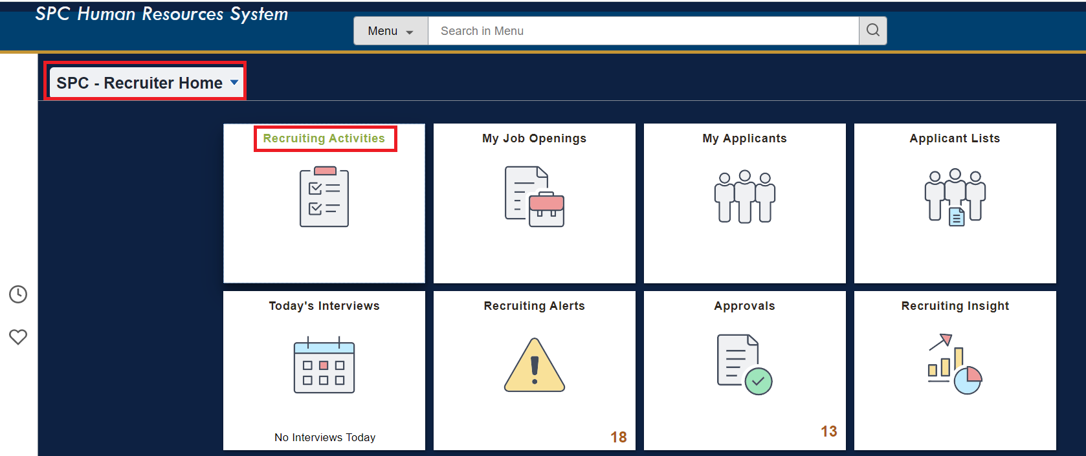  Hiring Managers: Manager Self Service (Tile) > Recruiting Activities> Search Job Openings  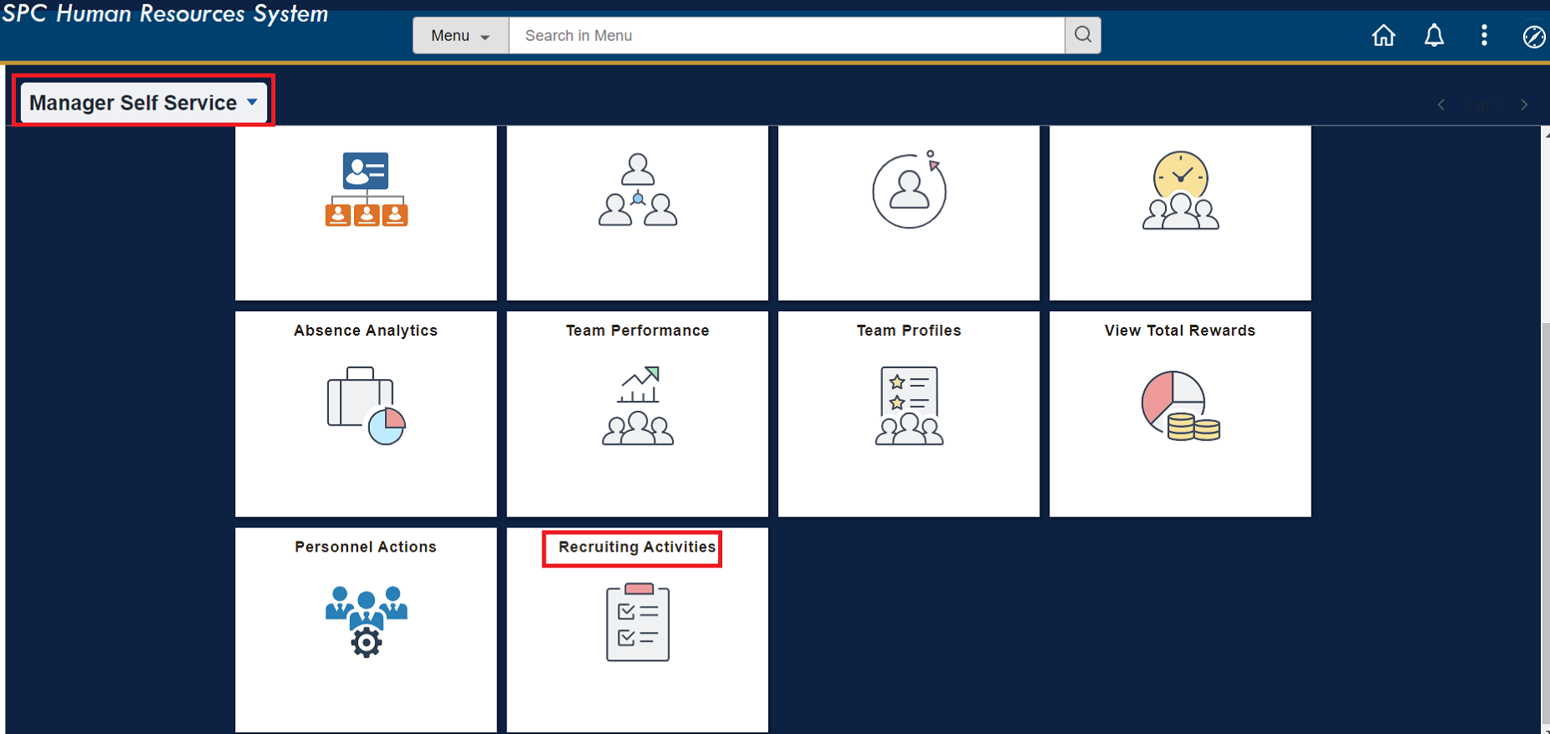  Alternatively, the Job Openings can be accessed using the Navigation Bar to the right using the below path:  - Main Menu > Recruiting > Search Job Opening  - Main Menu > Recruiting > Browse Job Opening  Manage Job Opening page provides a centralized view to access and manage applicants and their applications,  - Recruiting phase navigation bar lists all the recruiting phases and the count of applicants in each phase.  - ‘All’ tab lists all the applicants who have applied for the job  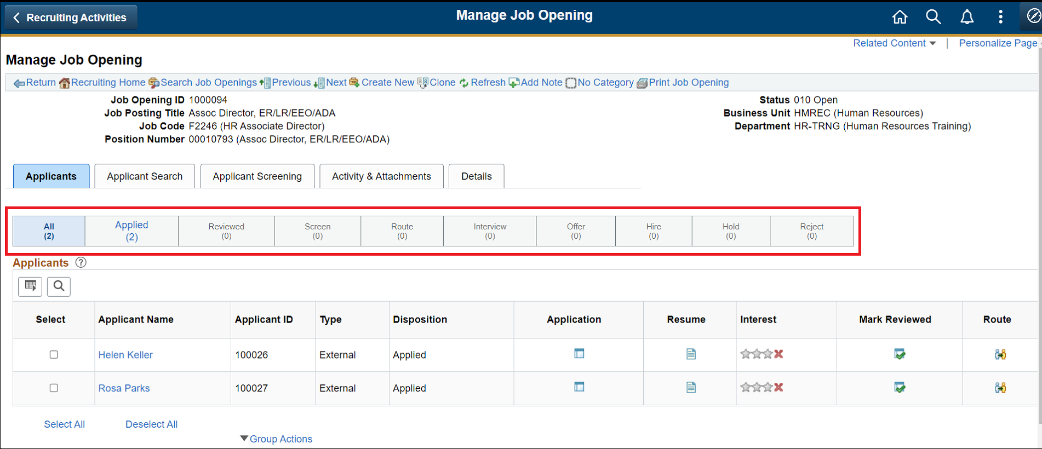
Step 2 | Accessing application Data  Use the following links on the ‘Applicants’ grid to view their data,  - Click on ‘Applicant Name’ hyperlink to view all data associated with an applicant  - Click on ‘Application’ icon to view data entered by applicant to this specific job application  - Click on ‘Resume’ icon to view the resume document attached to this specific application  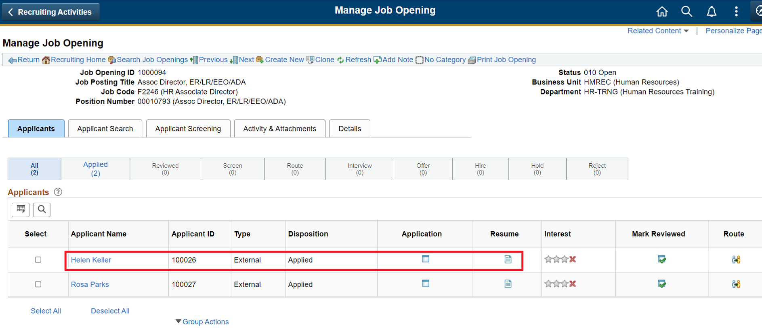
Step 3 | Recruiting Action – Mark Reviewed  Once an application has been reviewed perform recruiting action ‘Mark Reviewed’. This action is primarily used to note an application has be reviewed and is awaiting further action.  This action can be performed individually using ‘Mark reviewed’ icon against each application or a group action against multiple applications.  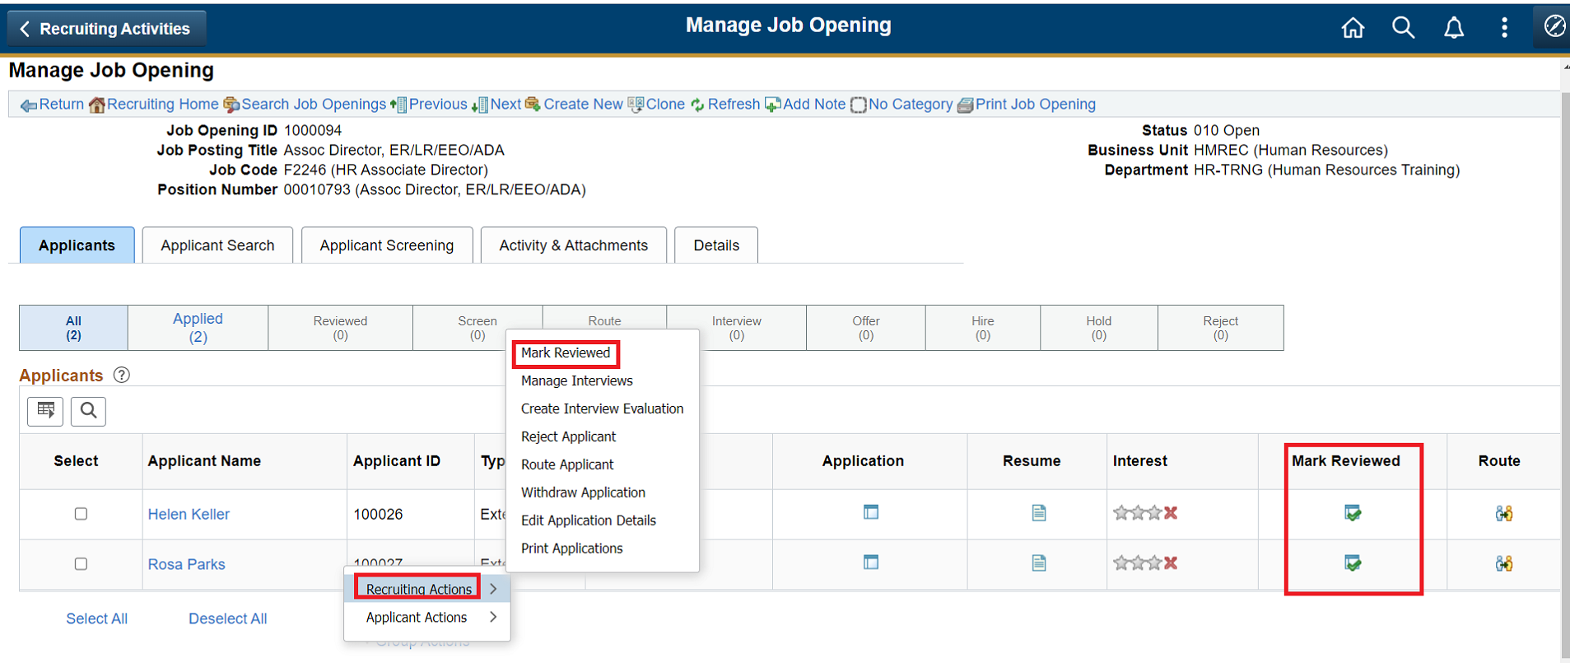  On performing the recruiting action a message appears indicating whether the update was successful or failed with any errors.  On successful completion, this recruiting action updates the disposition status to ‘Reviewed’ and the application appears under ‘Reviewed’ phase in the navigation bar.  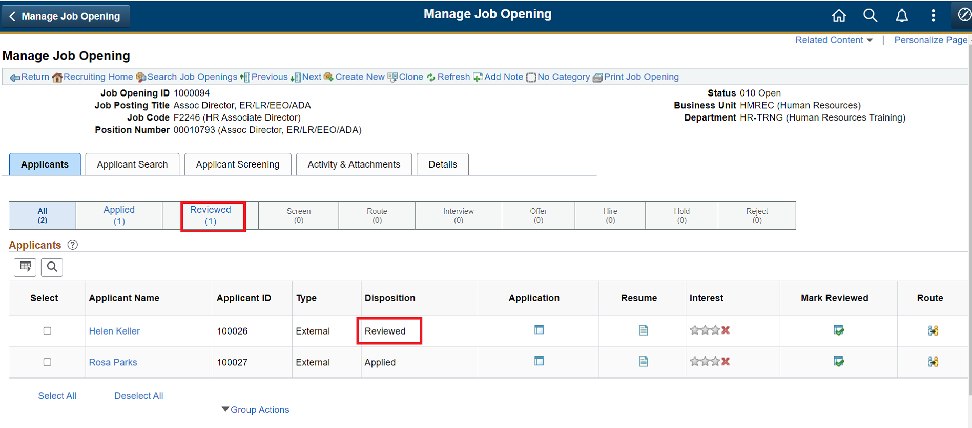  Note:  It is common practice to move all applications to ‘reviewed’ status, even if they have to be rejected outright. Recruiting action ‘Reject’ is commonly available only for ‘reviewed’ applications.
Step 4 | Recruiting Action – Route Applicant  ‘Route Applicant’ action is used to forward an applicant to reviewer(s) with an intention of receiving recommendation. Reviewers can be any employee with access to self-service.  This action can be performed individually using ‘Route Applicant’ icon against each application or a group action against multiple applications.  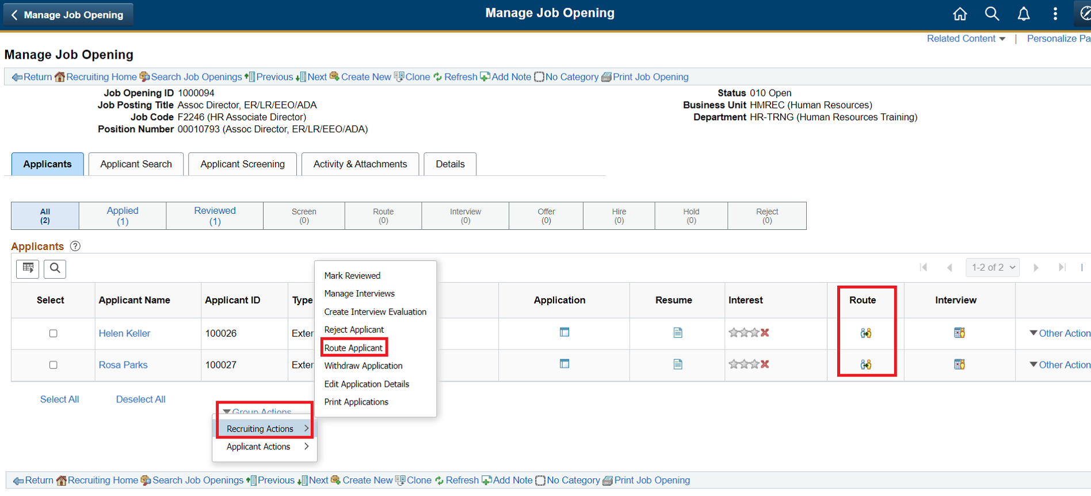  When ‘Route Applicant’ action is performed user is directed to a detailed page to provide to complete the action.  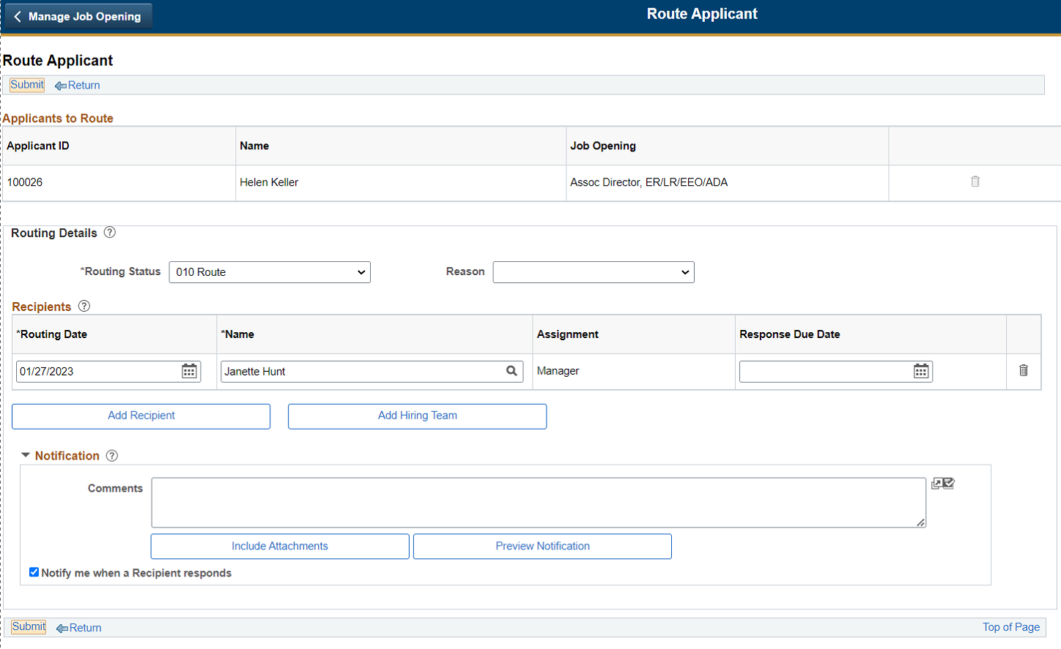  - Routing Status is defaulted based on system configuration  - Select a reason from pre-configured list  - In the ‘recipient’ grid add one or more reviewers  - either identifying them individually using a name lookup  - or from the list of users who are part of the hiring team for the particular job opening  - Optionally enter a ‘Response Due Date’ & ‘Comments’  - Use ‘Include Attachments’ option to select the list of documents to be included with the routing request. Based on the attachment type selected, all documents attached by the applicant under corresponding attachment types will be made available to reviewers. Reviewers can access these documents from ‘Routing Response’ self-service page, optionally select ‘send via email’ to include the documents in the notification email sent to reviewers when the routing request is submitted.  - Select ‘Notify me when a Recipient responds’ option to receive an email notification when a reviewer responds to the request  - Submit the ‘Routing request’ after entering required data. On successful completion of recruiting action below message appears,  - On successful completion, this recruiting action updates the disposition status to ‘Route’ and the application appears under ‘Route’ phase in the navigation bar.  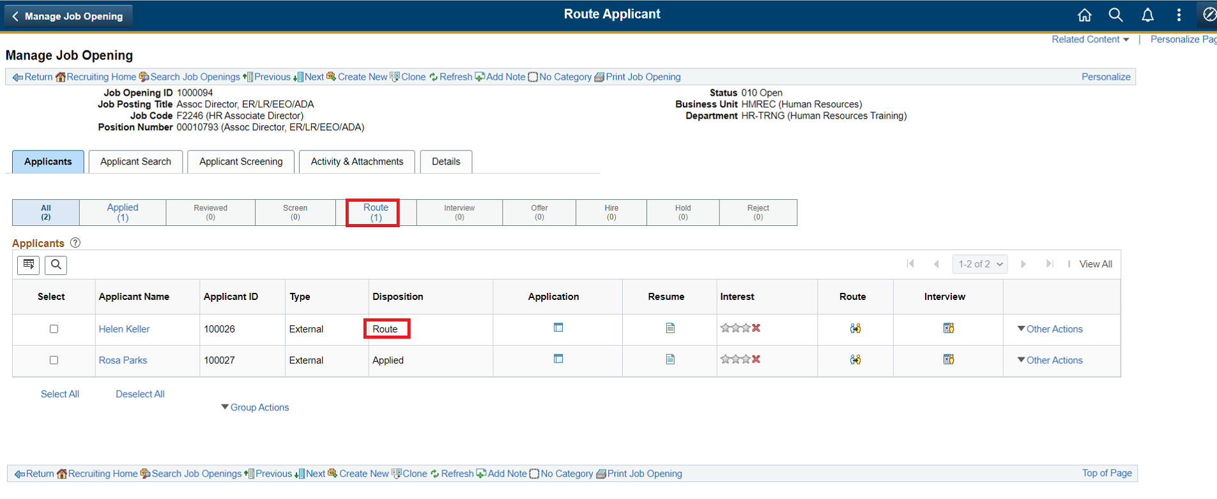  Note:  - On successful completion of routing action an email notification is sent to the reviewer(s) including the comment and attachments as entered on the routing request page.  - Reviewers will be able to respond to the routing request from the self-service ‘Routing Response’ page. Work instructions of reviewers is covered in separate document.  - Route Applicant can be performed multiple times on an application to forward it different sets of user.
Step 5 | Manage Routings  Once an applicant has been routed, clicking the ‘Route’ icon for the application opens ‘Manage Routings’ page. 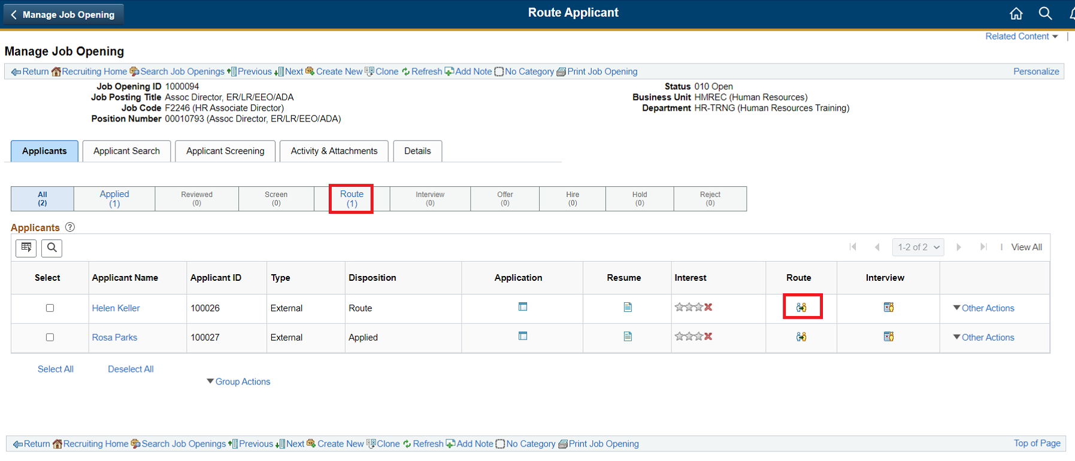  ‘Manage Routings’ page provides a summary view of the routing request(s) and the response for the application.  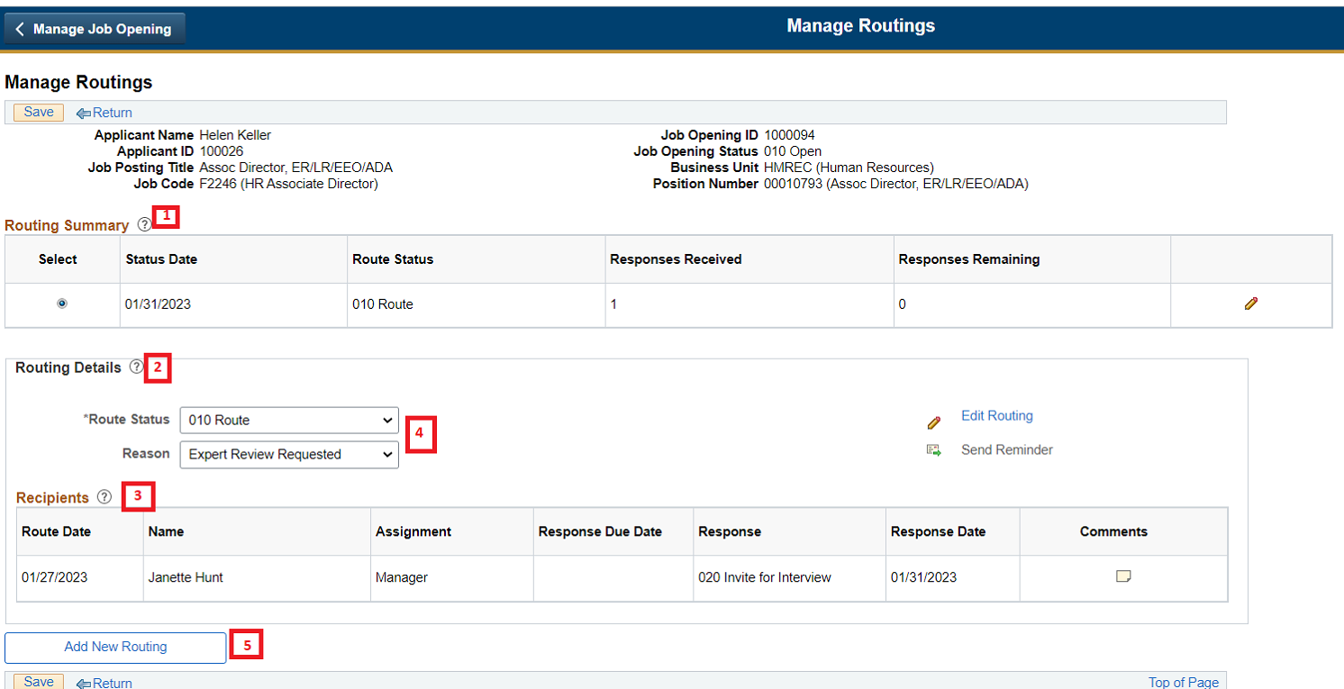  - Routing Summary grid - Displays all the routing requests submitted for the application. It shows the overall status of the request, total number of responses received and pending  - Routing Details grid – Displays the details of the routing request which is selected in the routing summary grid. It displays the overall route status and reason and a ‘recipient grid with responses.  - Recipient grid – Displays the individual response received from each reviewer. This summary helps user to make an overall decision based on reviewer(s)’ recommendations.  - After evaluating the response from reviewers, optionally update the ‘Route Status’ of the routing to a suitable state. E.g. if the majority of response received favour an applicant for interview, then set the overall route status to ‘highly recommend for interview’  - Use ‘Add New Routing’ option to create a new routing request
Step 6 | Recruiting Action – Manage Interviews (New Schedule)  This action can be performed individually using ‘Manage Interviews’ icon against each application or a group action against multiple applications.  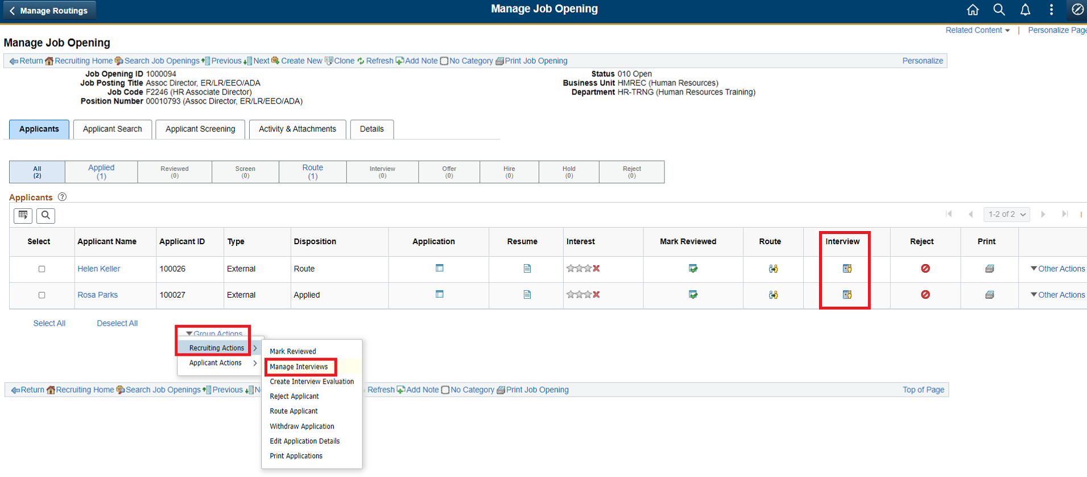  Performing ‘Manage Interview’ recruiting action opens an interview schedule page,  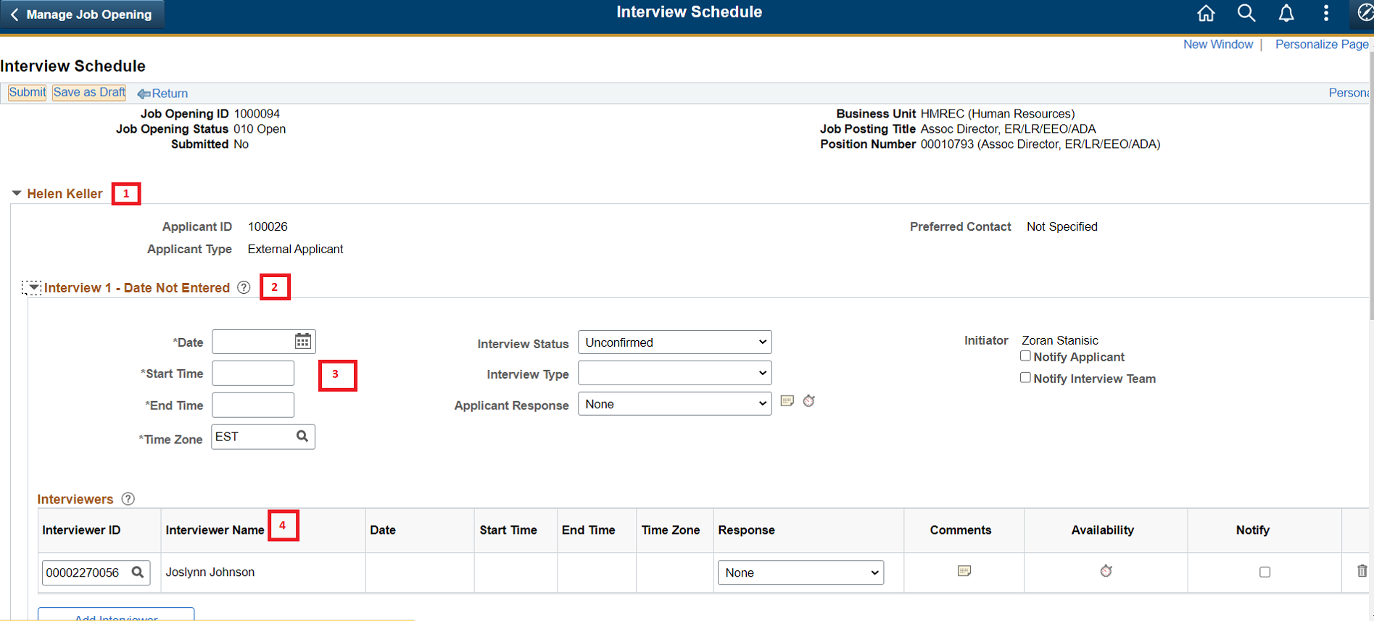  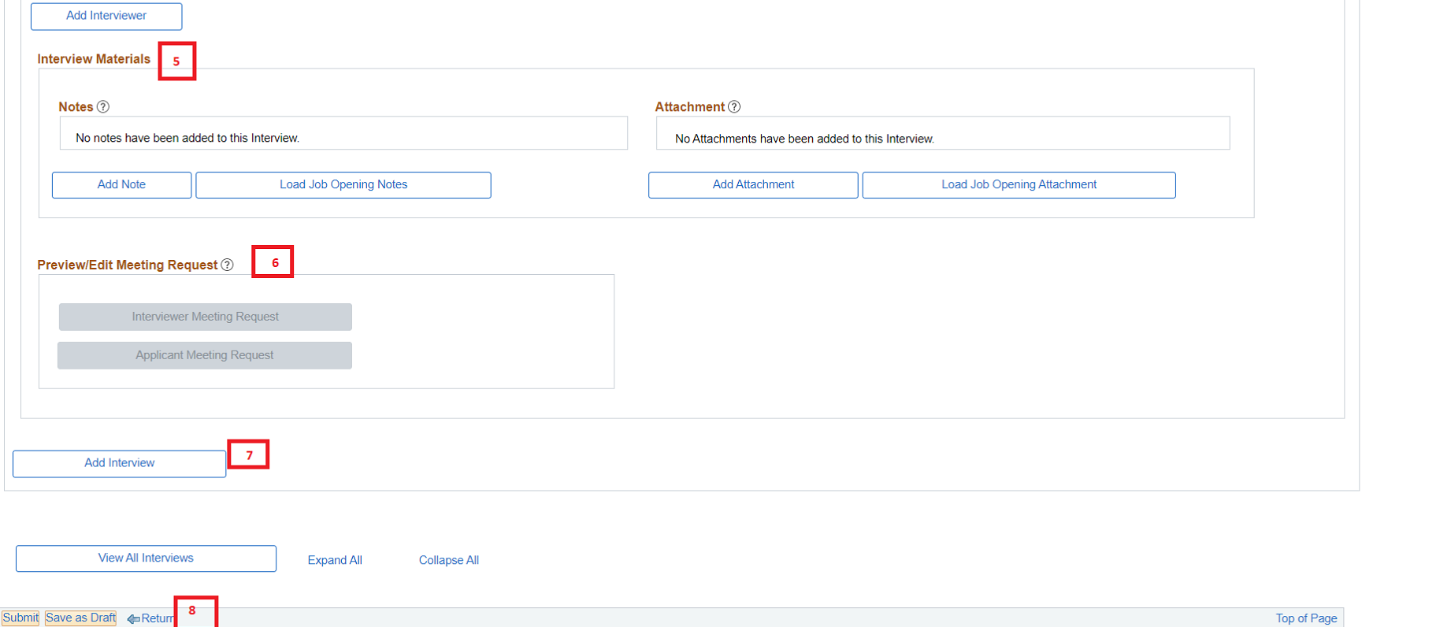  Interview schedule page is designed to create and manage one or more interviews for one or more applicants in single view.  - Applicant level group box is labelled with applicant name and is provided with an expand/collapse toggle button  - Interview level group box is labelled with an interview number and date and is provided with an expand/collapse toggle button  - Enter date, time to schedule an interview. Optionally enter interview type and notification flags  - ‘Interviewers’ grid allows user to add multiple ‘interviewers’ and ability to enter individual comments and notification option  - ‘Interview materials’ section allows user to add notes and attachments either locally from user computer or use documents that is already available in the job opening. Note this section can only be used after saving an interview.  - User ‘Add Interview’ option to create another interview for the applicant.  - User ‘Preview/Edit meeting Request’ section to view, update or add attachments to the email notifications to applicant or interview team. This section is available only after the interview schedule is saved.  - Use ‘Save’ or ‘Submit’ option after entering all the required details.  Note:  If needed, fields on the Interview schedule page – Applicant Response, Interviewers Grid – Response, Venue Information Section – Response, will have to be manually maintained by the user if ‘Full Calendar Integration’ is not enabled in the installation.  On successfully submitting an interview schedule a confirmation message is shown,  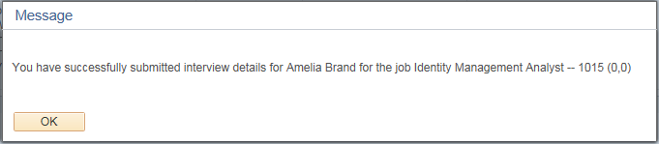  On successful completion, this recruiting action updates the disposition status to ‘Interview’ and the application appears under ‘Interview’ phase in the navigation bar.  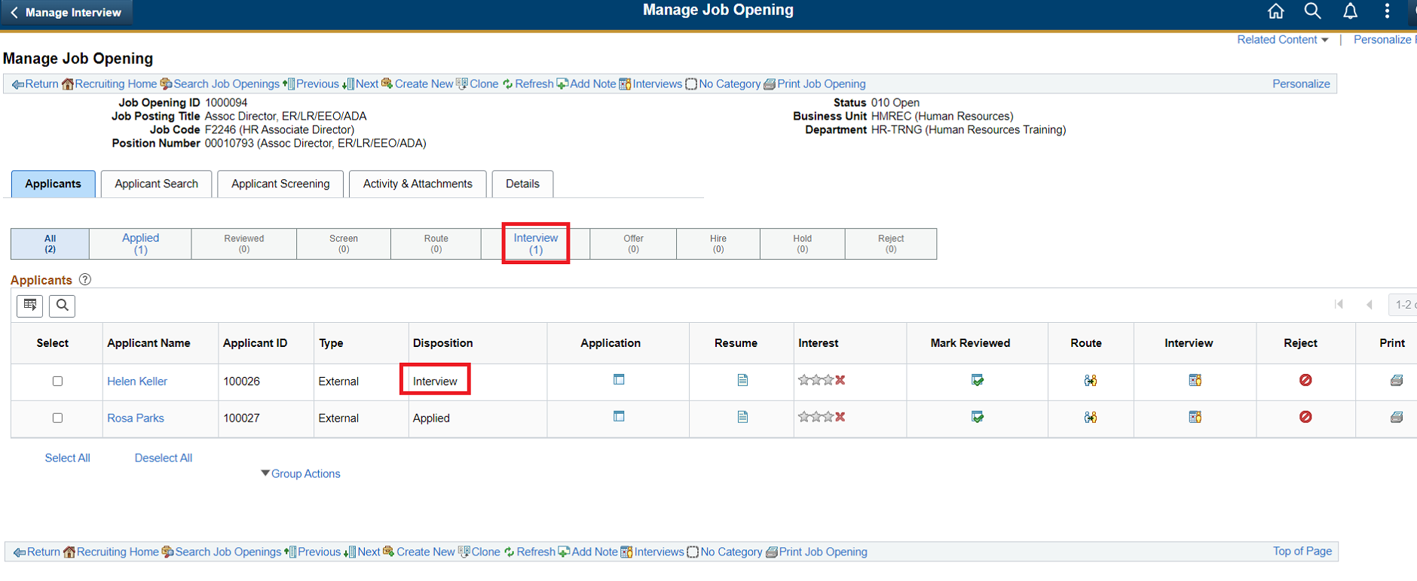
Step 7 | Recruiting Action – Manage Interviews (Existing Schedule)  For an applicant who has an interview schedule created, clicking on the ‘Manage Interview’ icon or performing a ‘Manage Interview’ group action opens ‘Manage Interviews’ page.  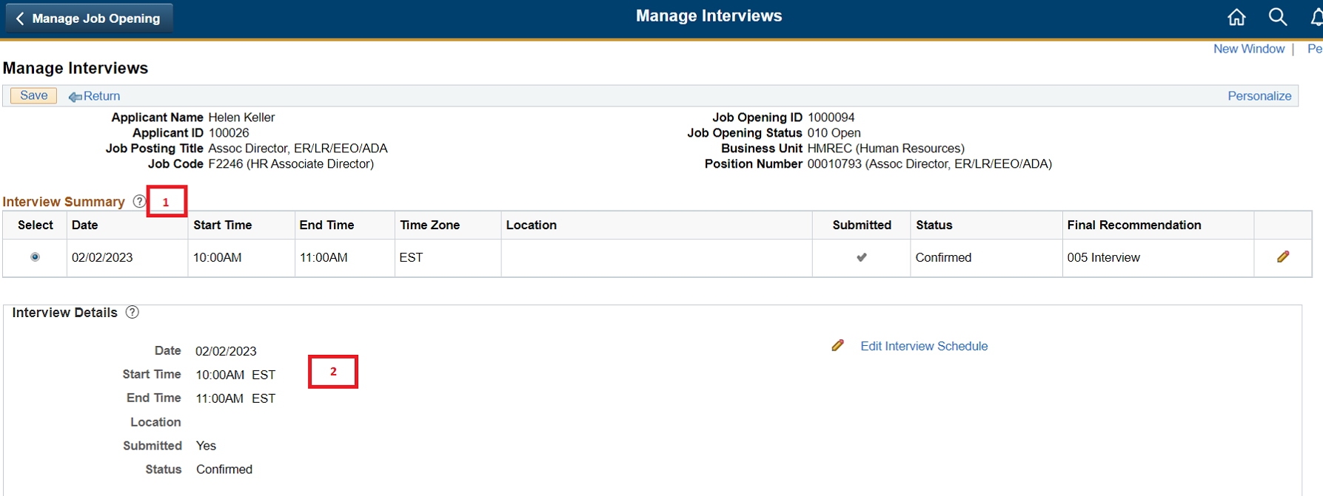  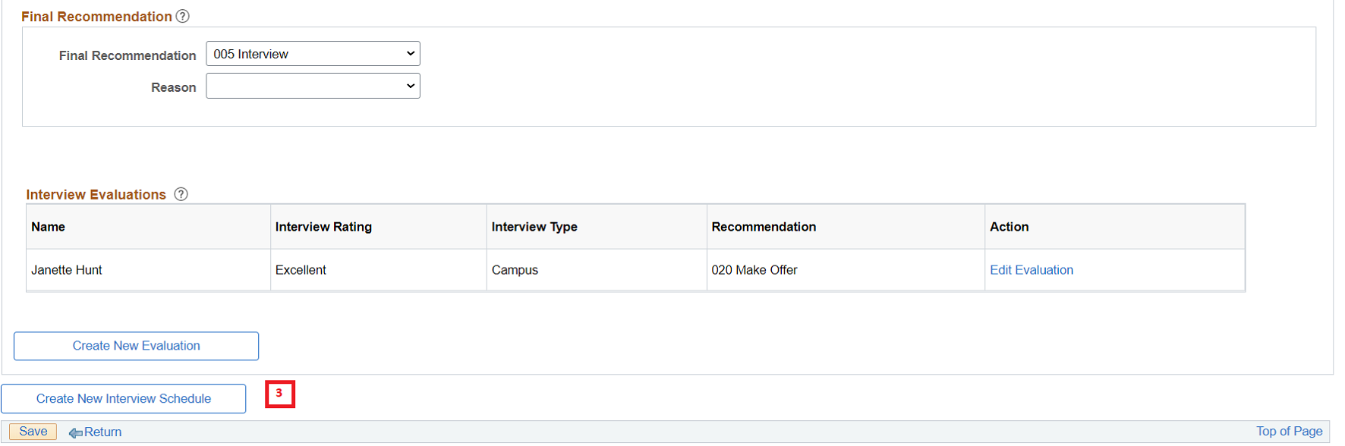  - Interview Summary Grid – lists the interviews scheduled for the applicant with an option to edit  - Interview details section – For the Interview schedule selected in the summary grid, this section provides a brief summary of the schedule.  - Final Recommendation section – Allows user to enter a final recommendation and reason and displays the average score based on interview evaluations  - Interview Evaluation Section – Displays the list of evaluations received for the interview  - Use ‘Create New Evaluation’ if required to create and submit a new evaluation.  - Use ‘Create Interview Schedule’ option to create and submit a new interview schedule  Note:  Final recommendation is used to record the overall decision based on individual evaluation responses. Setting a final recommendation doesn’t update the disposition status of the applicant.
Step 8 | Recruiting Action – Prepare Job Offer (New offer)  Perform recruiting action ‘Prepare Job Offer’ on selected applicant individually as shown below. This action cannot be performed as a group action on multiple applicants.  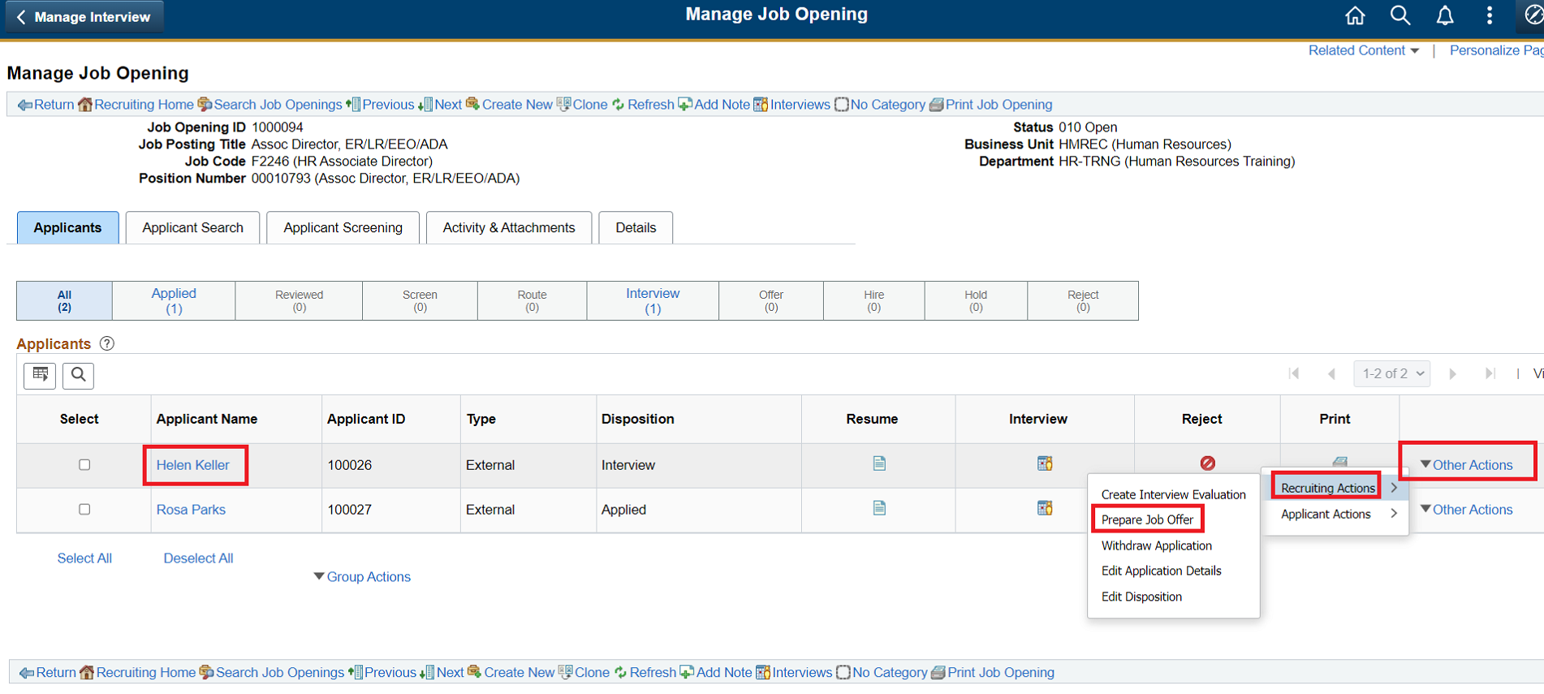  Performing this recruiting action opens a ‘Prepare Job Offer’ page,  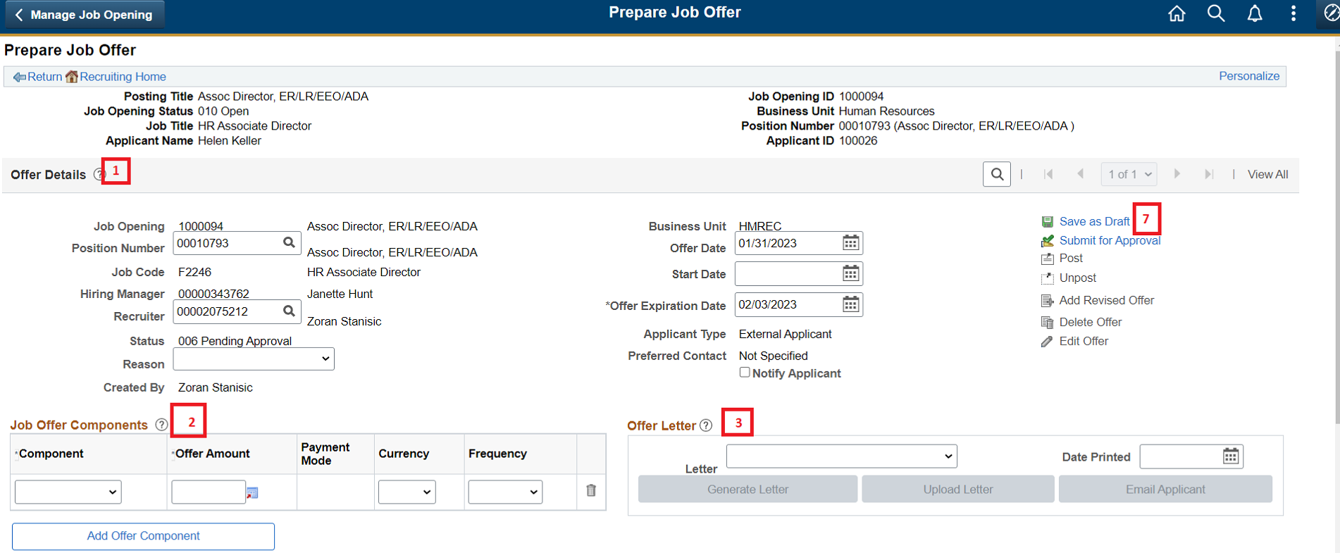  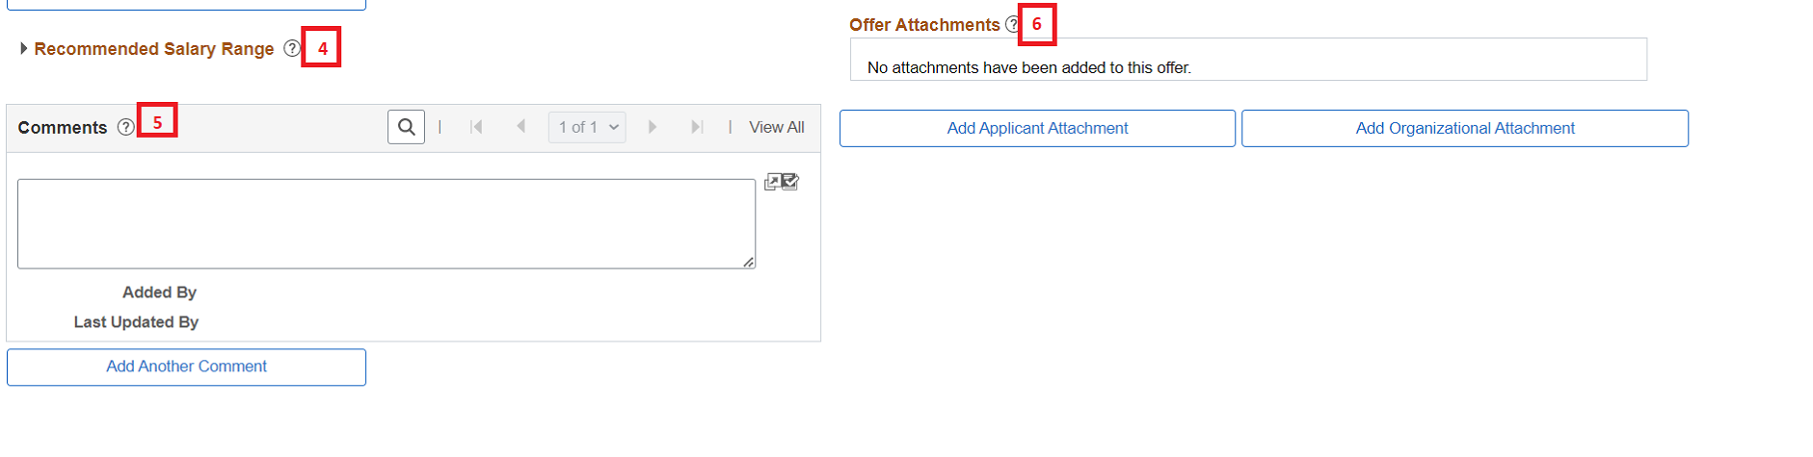  - Offer Details section – Contains various data fields that forms a job offer. Fields like Position, Jobcode, Hiring Manager and recruiter are copied from the Job opening.  - Use Job Offer Components grid to add multiple offer components (monetary) from a pre-configured list of options.  - Use ‘Offer Letter’ section to choose a template to be used for offer contract generation.  - Recommended salary range section provides a display only view of salary range based on the position/Jobcode configuration (if configured in HR module)  - Use comments section to enter relevant user comments.  - Use Offer attachment section to attach documents that can be sent to applicants once the offer is approved.  - Use the links on the right hand side to ‘Save’ or ‘Submit’ an offer for approval
Step 9 | Recruiting Action – Prepare Job Offer (Saved/Submitted Offer)  Performing a recruiting action of ‘Prepare Job Offer’ for an applicant who already has an offer created opens the ‘Prepare Job Offer’ page in read-only mode.  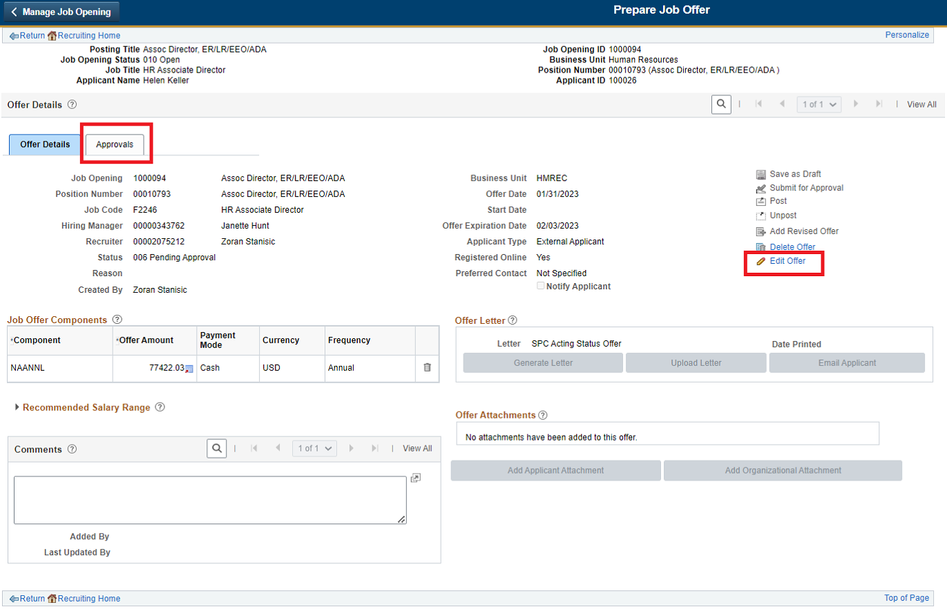  - Use the link ‘Edit Offer’ to make changes to the offer and depending upon the security configuration user will be able to save/submit the offer.  - Use the ‘Approvals’ tab on the Offer details page to view approval workflow status and perform approval action (approval actions available only if uses is a valid approver)  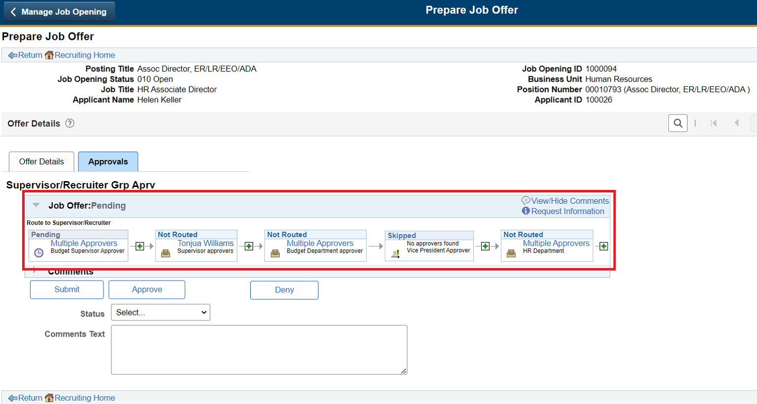Approval tab provides a visual representation of the approval workflow indicating the  - Overall approval status  - Approvers at various step  - Status of each step.  Note:  Work instruction to approve Job Offers and Job Openings are covered in a separate document
Step 10 | Recruiting Action – Prepare Job Offer (Approved offer)  When a Job Offer is approved by all the approvers as configured in the workflow, applicant disposition is updated to ‘Offer’ status and the applicant is accessible in the ‘offer’ phase of the navigation bar.  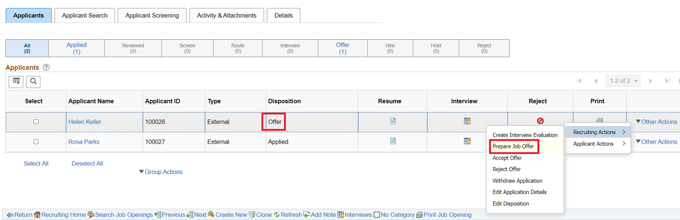  Use ‘Prepare Job Offer’ recruiting action to access the approved offer.  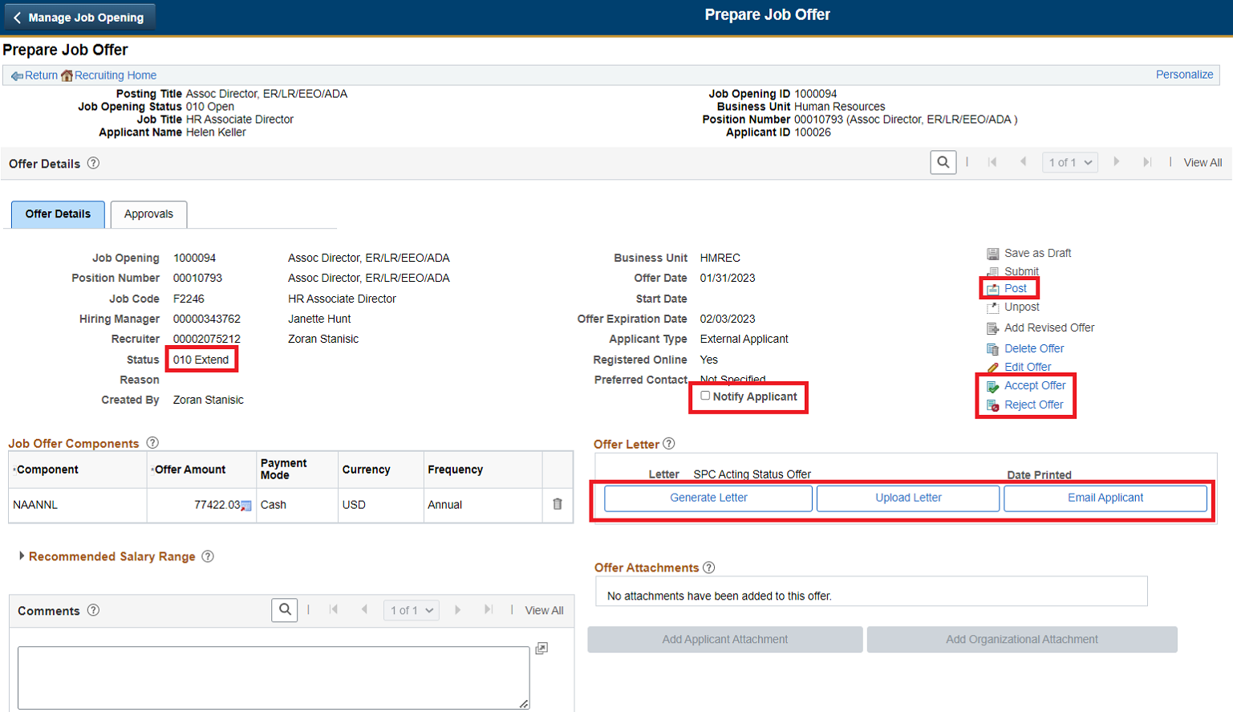  - Offer Status is set to ‘010 Extend’  - ‘Post’ hyperlink is now enabled (Only if applicant has registered online via candidate gateway)  - ‘Notify Applicant’ is now enabled (Only if applicant has registered online via candidate gateway)  - ‘Accept Offer’ and ‘Reject Offer’ is enabled  - Offer Letter section now has ‘Generate Letter’, ‘Upload Letter’ and ‘Email Applicant’ option enabled.  Note:  Even though ‘Edit Offer’ link is enabled on an approved offer, using edit option to make changes may re-trigger the workflow approval process.
Step 11 | Recruiting Action – Prepare Job Offer (generating offer letter)  - Use ‘Generate Letter’ option in ‘Offer Letter’ section to generate an offer contract document based on the template chosen in ‘letter’ field.  - When an offer letter is generated ‘Date Printed’ field is updated to system date and the physical file generated is made available in the ‘Attachments’ grid  - After generating a letter, download the document and make changes as necessary and upload it using ‘Upload letter’ link
Step 12 | Recruiting Action – Prepare Job Offer (Offering Applicant)  - For applicants who have ‘Registered Online’ – Use ‘Notify Applicant’ check box and ‘Post’ hyperlink to send an email notification and post the offer on candidate gateway  ‘Post Online Job offer’ page provides the summary view of the data to be posted in candidate gateway.  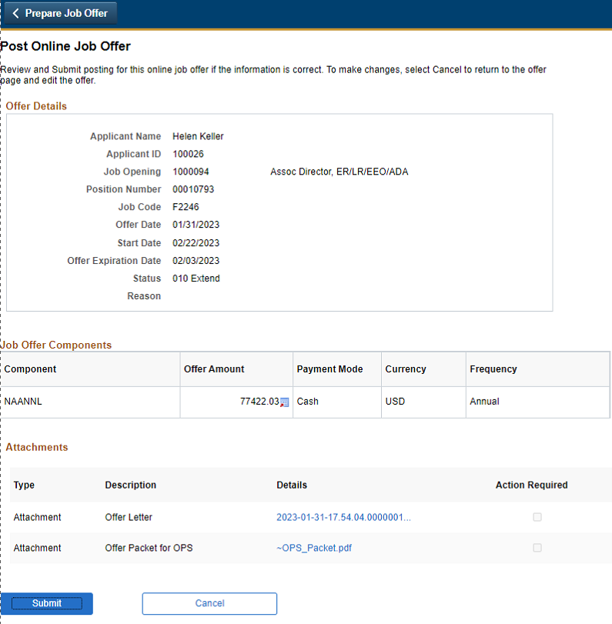  Note:  For applicant who is registered online – Use ‘Email Applicant’ option on the ‘offer Letter’ section to manually send an email with the generated offer documents as attachment.
Step 13 | Recruiting Action – Prepare Job Offer (Un-post Offer)  A job offer that has been posted online to candidate gateway can be withdrawn if required.  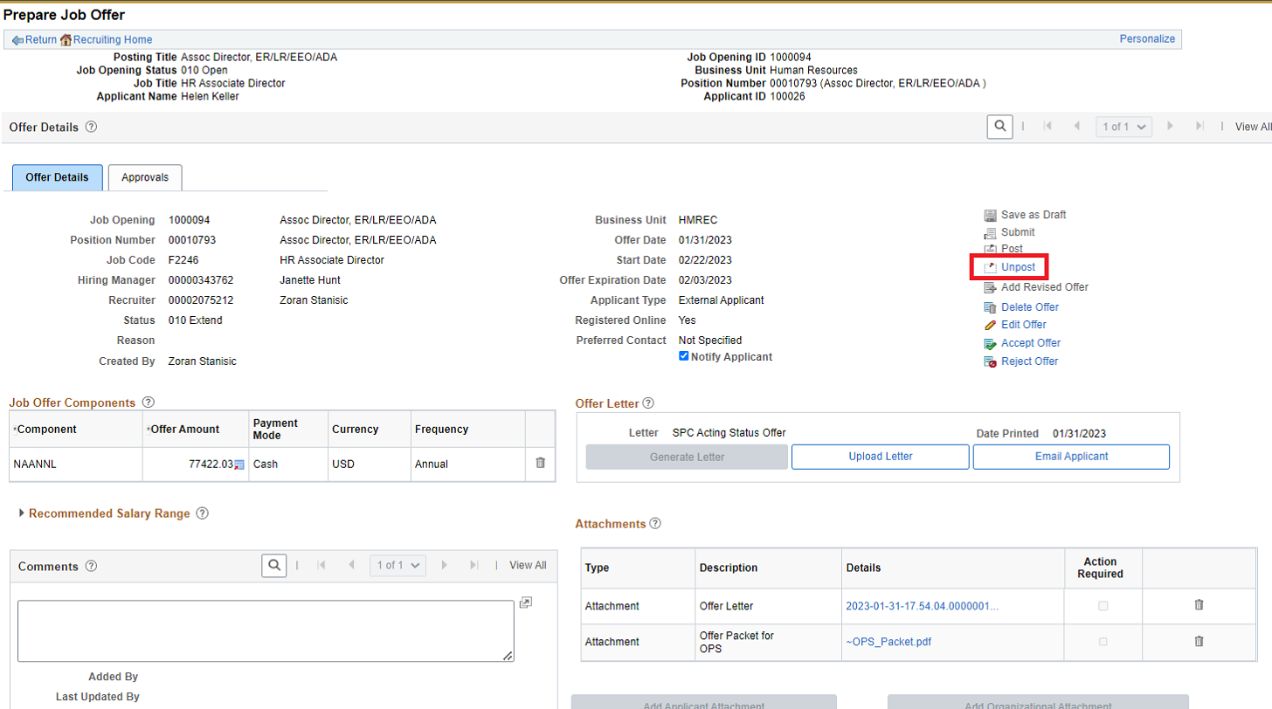
Step 14 | Recruiting Action – Accept Offer / Reject Offer  For applicants who have disposition status ‘offer’ (who have been offered), recruiting actions ‘Accept Offer’ & ‘Reject Offer’ is available.  Recruiting user can perform either of this action ‘on-behalf’ of applicants, commonly used for applicants who did not register online and received an offer via email. Response to the offer is recorded manually by this action.  Applicants who have received the offer online can accept or reject the offer thru Candidate Gateway portal and the disposition status of the applicant is updated accordingly. (No need to perform this recruiting action)  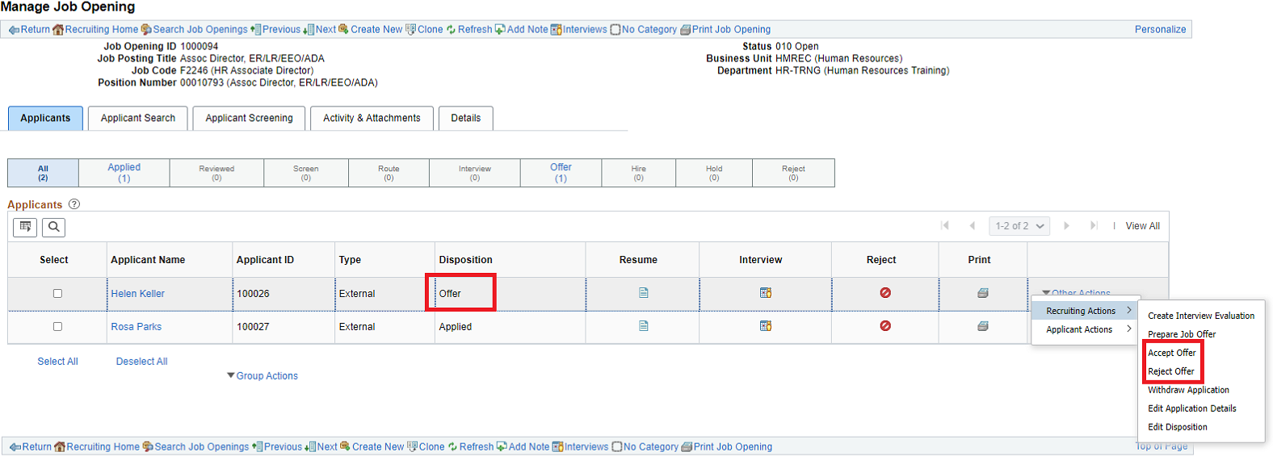  When ‘Accept offer’ or ‘Reject Offer’ action is performed a reason can be entered (if configured).  On successful completion of recruiting action applicant’s disposition status is updated (Accepted or Rejected)  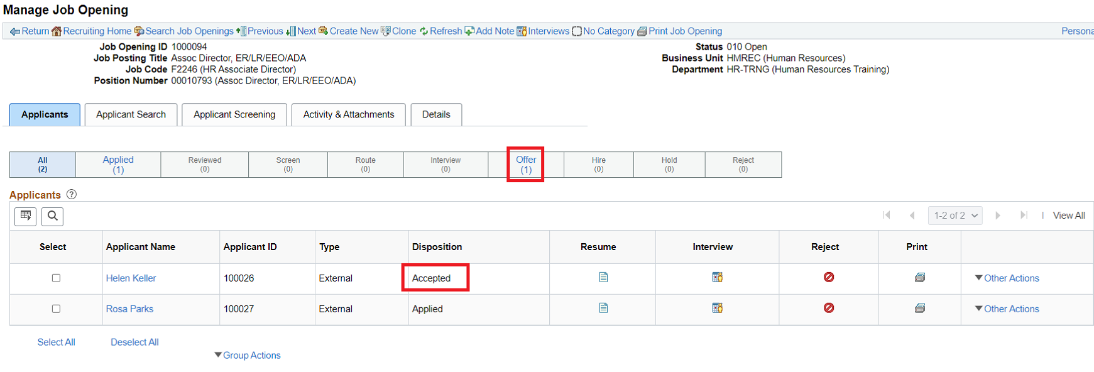
Step 15 | Recruiting Action – Prepare for Hire  For applicants who have disposition status ‘Accepted’, recruiting action ‘Prepare for Hire’ is available.  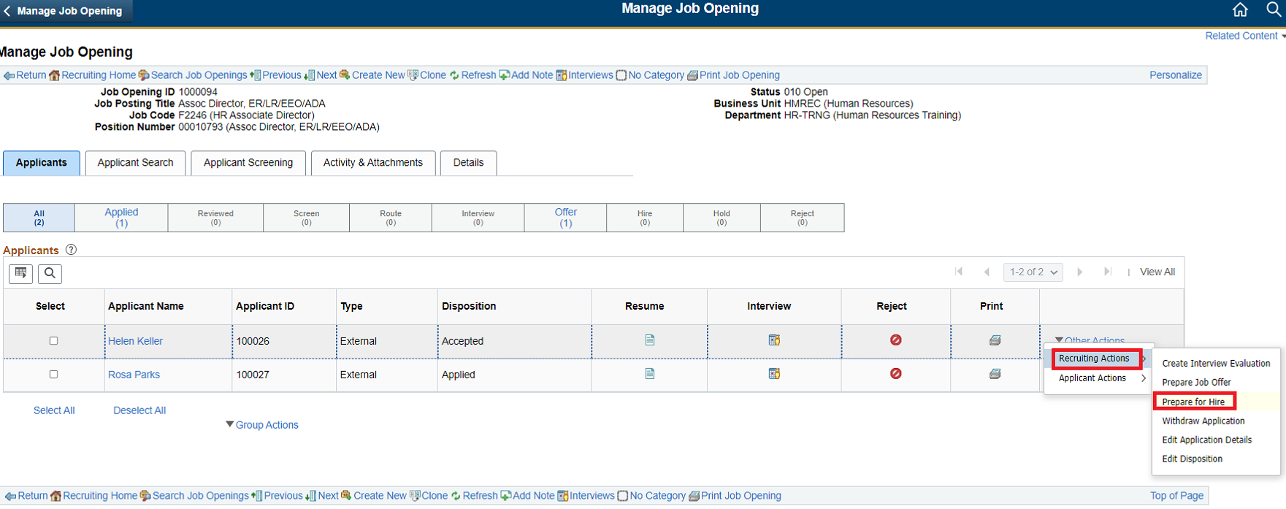This action is used to submit an applicant to HR module for Hire process (Manage Hires).  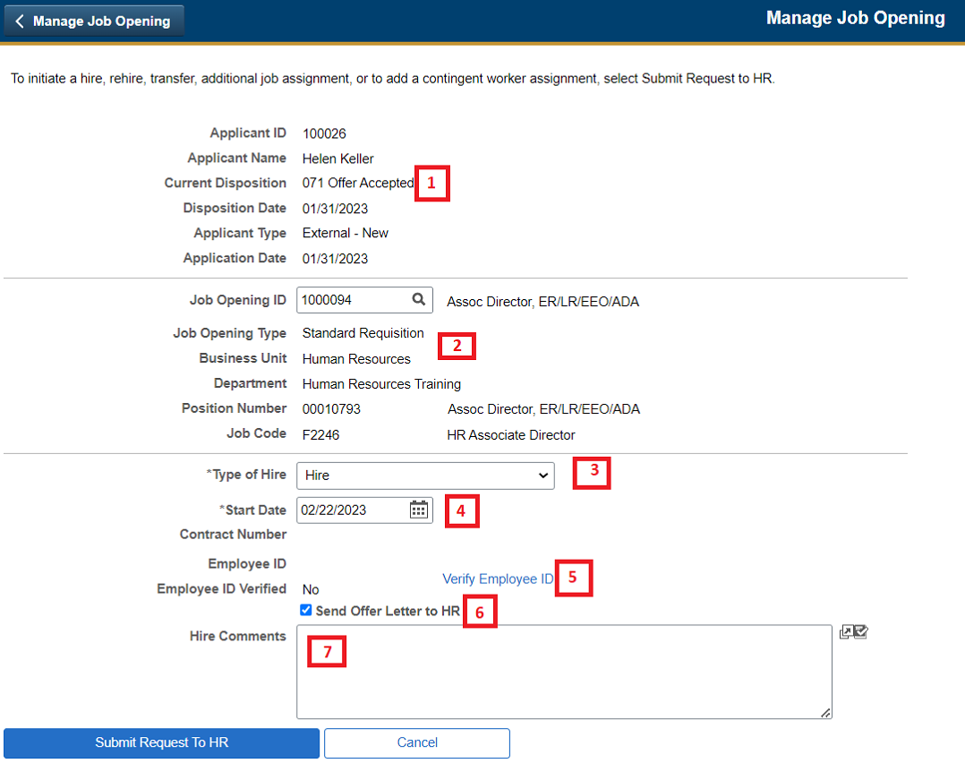  - Applicant information is available in a read-only view  - Job Opening Id derives the related job data attributes like Position Number / Jobcode etc.  - Enter ‘Type of Hire’ from a pre-configured list. Available options vary for internal and external applicants.  - Start Date is defaulted from Job Offer  - “Verify Employee Id” performs a search based applicant’ name and date of birth to identify any possible matches for the applicant in the system. This step is useful in preventing duplicate person id created in HR module for the same person.  - This step can be performed either in this page or in the manage hires page (before hiring)  - When ‘Verify employee Id’ identify a possible match and if the user selects the Employee Id then ‘Employee Id’ field is populated, else left blank.  - ‘Employee ID Verified’ flag is set ‘Yes’ if the User performs this step.  - Use flag ‘Send Offer Letter to HR’ to make the job offer letter for the applicant available to HR in the ‘Manage Hires’ page  - Use ‘HR Comments’ to provide additional information.  Confirmation on submitting the form.  On successful completion, this recruiting action updates the disposition status to ‘Ready’ and the application appears under ‘Hire’ phase in the navigation bar.  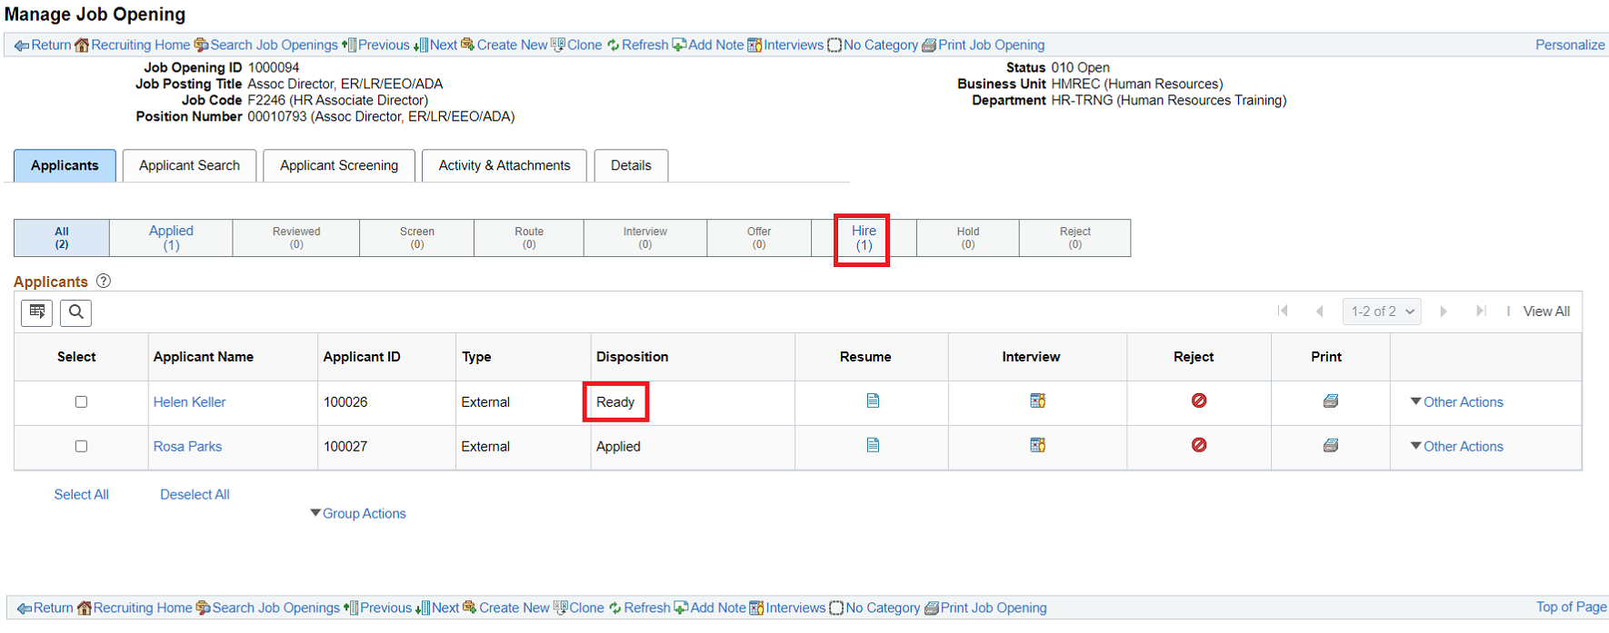  Note:  - When an applicant’ disposition status is ‘Ready’ they are available for hiring in the ‘Manage Hires’ page, work instruction for ‘Manage Hires’ is covered in a separate document.  - When the applicant is hired thru ‘Manage Hires’ function, disposition status of the applicant is automatically updated to ‘Hired’
Step 16 | Recruiting Action – Reject Applicant  An application can be rejected at any phase of the recruitment process prior to offer phase.  Recruiting action ‘Reject Applicant’ can be performed either for an individual applicant using the ‘Reject Icon’ or as a group action for multiple applicants.  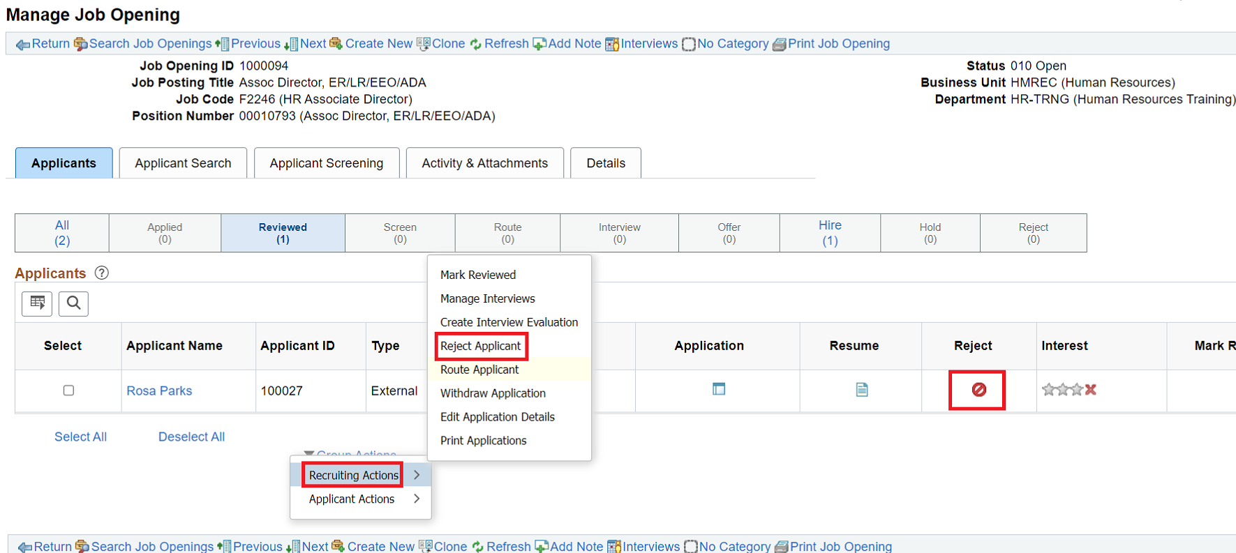  When ‘Reject Applicant’ action is performed,  - ‘Reason’ is a mandatory field for user entry – pre-configure list of values  - Use ‘Reject’ option to complete the reject action – No Notification is sent to applicant  - Use ‘Reject and Correspond’ option to send a correspondence to the applicant informing the decision  When ‘Reject and Correspond’ option is selected user is directed to applicant correspondence page.  - Select pre-configured letter templates from the drop-down appropriate to the correspondence  - Enter ‘Subject’ for the email notifications.  - Message section of the email is auto-populated if a letter template is selected, optionally use can manually enter a message.  - Optionally, add attachments to the notification  - Preview or send the notification.  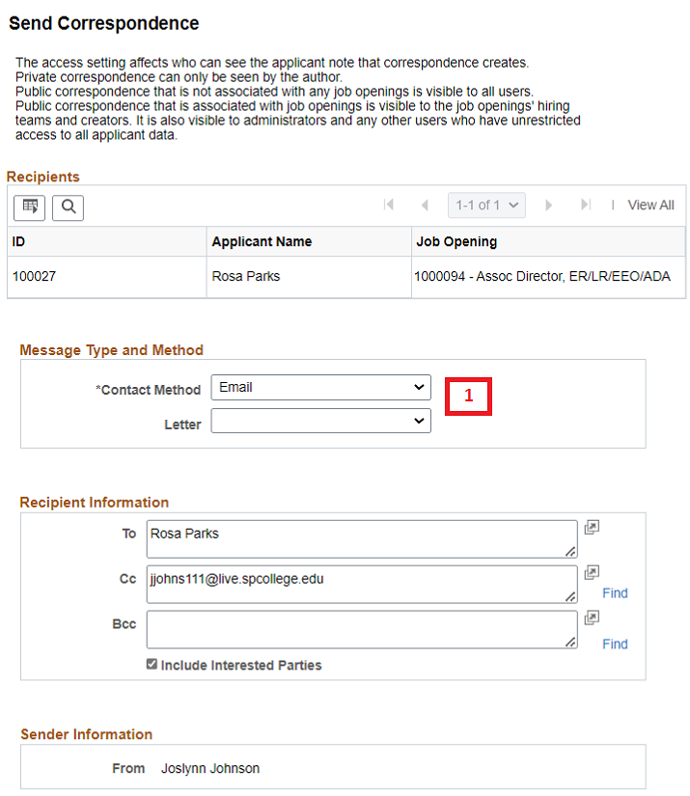  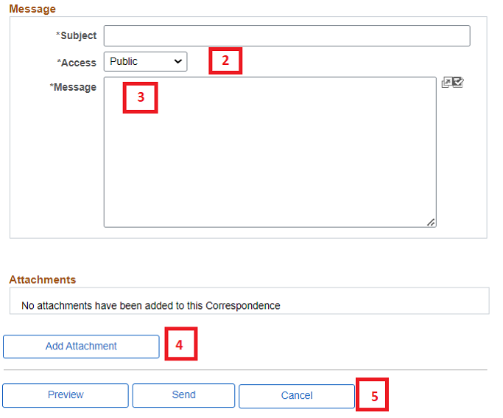  When ‘Reject’ or ‘Reject and Correspond’ action is completed a notification is displayed.  On successful completion, this recruiting action updates the disposition status to ‘Reject’ and the application appears under ‘Reject’ phase in the navigation bar.
Step 17 | Recruiting Action – Withdraw Application  An application can be ‘withdrawn’ at any phase of the recruitment process.  Recruiting user perform this action ‘on-behalf’ of applicants, commonly used for applicants who did not register and apply online and applied via email.  Applicants who have registered and applied online can withdraw application thru Candidate Gateway portal and the disposition status of the applicant is updated accordingly. (No need to perform this recruiting action)  Recruiting action ‘Withdraw Application’ can be performed either for an individual applicant using the ‘Withdraw Applicant’ or as a group action for multiple applicants.  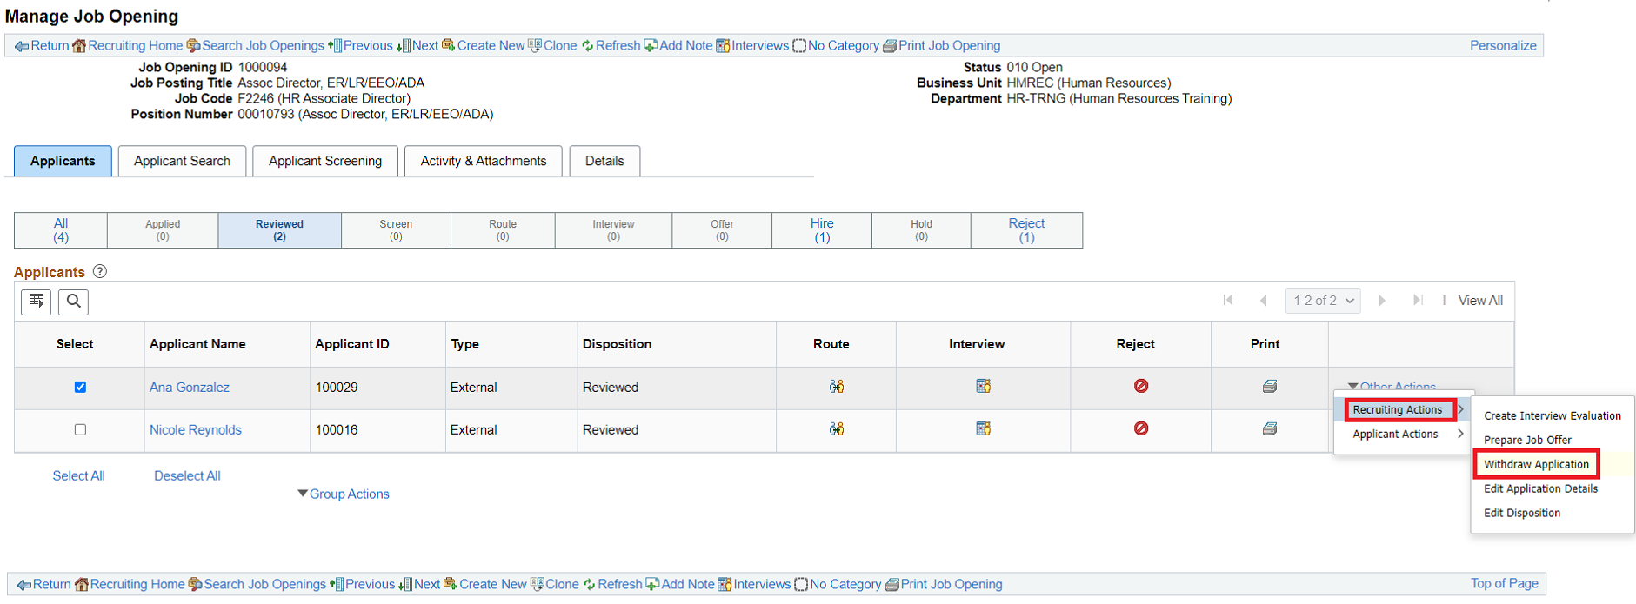  Performing ‘Withdraw Application’ recruiting action,  - Enter a reason from a pre-configured list  - Use ‘Withdraw’ option – To withdraw and not notify applicant  - Use ‘Withdraw and Correspond” option – To withdraw and correspond with applicant  On successful completion, this recruiting action updates the disposition status to ‘Withdrawn Application’ and the application appears under ‘Reject’ phase in the navigation bar.  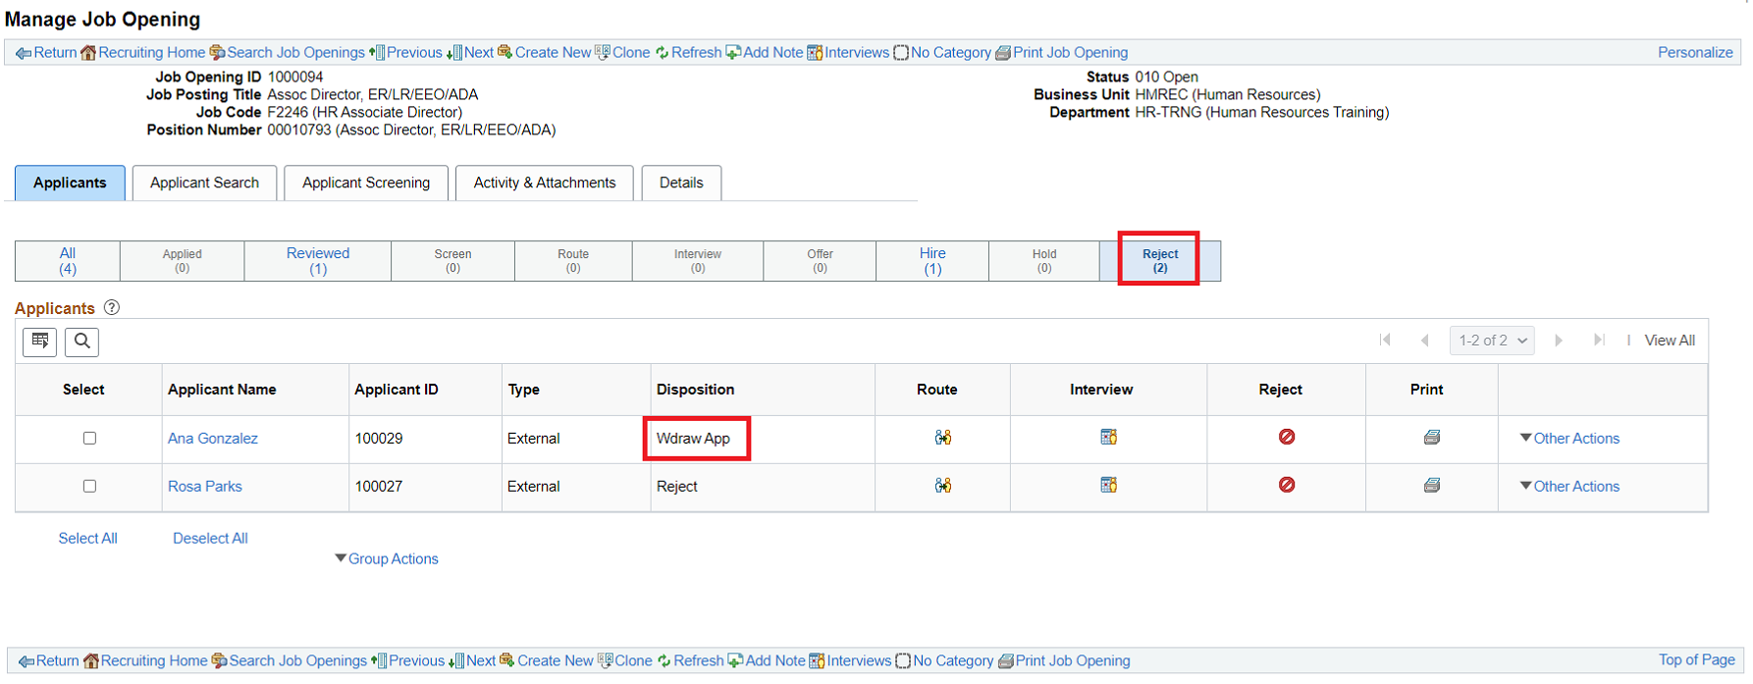
Step 18 | Recruiting Action – Edit Disposition  Dispositions identify an applicant’s status with regard to the recruiting process for a particular job opening. Actions for reviewing, screening, interviewing, making offers, and hiring automatically assign appropriate dispositions.  Sometimes, however, it is necessary to manually update an applicant’s disposition. To do this, use the Edit Disposition action.  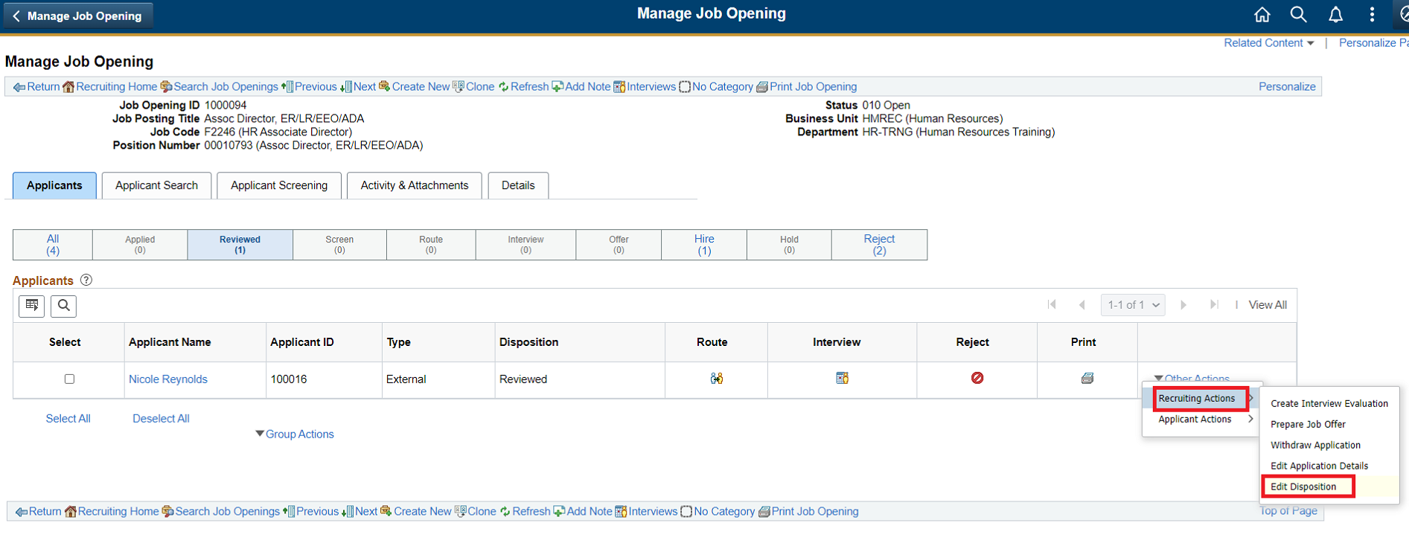  Edit Disposition page,  - Enter ‘New Disposition’ from a pre-configured list which varies depending on the current disposition status.  - Enter Status Reason depending the new status selected  E.g. Setting an application to ‘hold’ status using ‘Edit Disposition’ recruiting action.  