The following steps should be applied to all applicants:

- Hiring managers should be reviewing their applicants on a regular basis. After reviewing an application, they should mark the applicant as “reviewed” by clicking on the icon in the “marked reviewed” box.

- After the preliminary review, if the applicant is being rejected, they should then click on the icon in “reject” column.

- If the candidate is being further considered, then they should click on the icon in the “interview” column and set up the details date, time, etc. of the interview. *Please note, this is an IMPORTANT step. You will not be able to do make a final recommendation in the interview section unless you schedule the interview.

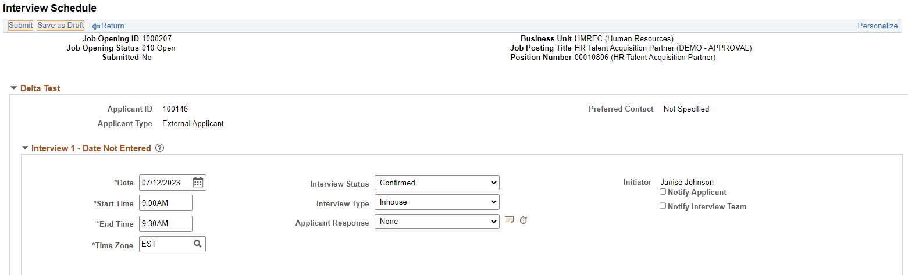

- Once the interview is completed, an interview evaluation form should be completed for the applicant. This is done by taking the drop down for “other actions”, then “recruiting actions”, then “create interview evaluation”. Once the evaluation form is finalized, they should “submit”.
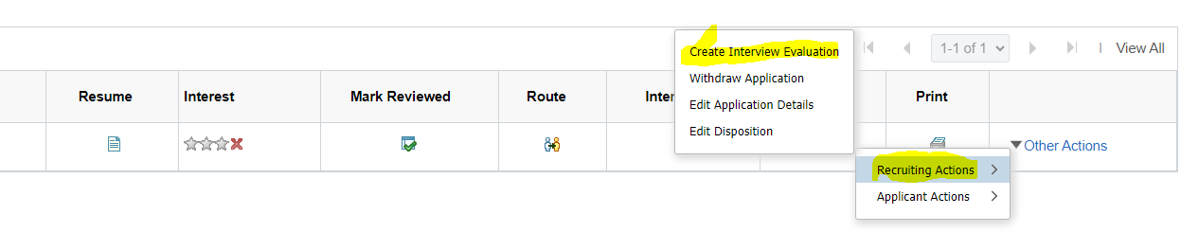

- To move forward with a final candidate, the manager will return to the “interview” icon. When this link is opened the manager will see the option to select a “final recommendation”. They should select “make offer”. By doing this, it will push this applicant into the HR queue. HR will then prepare the offer for approval. Once approval is received the offer letter will be generated through the recruitment module. The candidate will receive an email alerting him/her that an offer is awaiting. The candidate will log into his/her account on the career portal to view the offer and to accept/decline.

