Overview
Purpose  Why is this process in place? | This work instruction details how to create a Job Opening and submit it for approval.
Outputs  What does this process produce? | A new Job Opening with the status – ‘Pending Approval’. This activity is complete when the newly created Job Opening is submitted for approval.

Before you start
Roles this applies to | Recruiter  Hiring Manager
Prerequisite | A Job Opening requires either a Jobcode or Position Number to derive the job requirement.  - If the requirement is for a budgeted Position driven then either create or identify a Position to associate with the Job Opening  - If the requirement is not for a budgeted position, then identify a Job code to associate with the Job Opening

Navigation | - Login to SPC Human Resource System  - In the list of homepages, select ‘SPC Recruiter Home’  - In the list of tiles, select ‘Recruiting Activities’  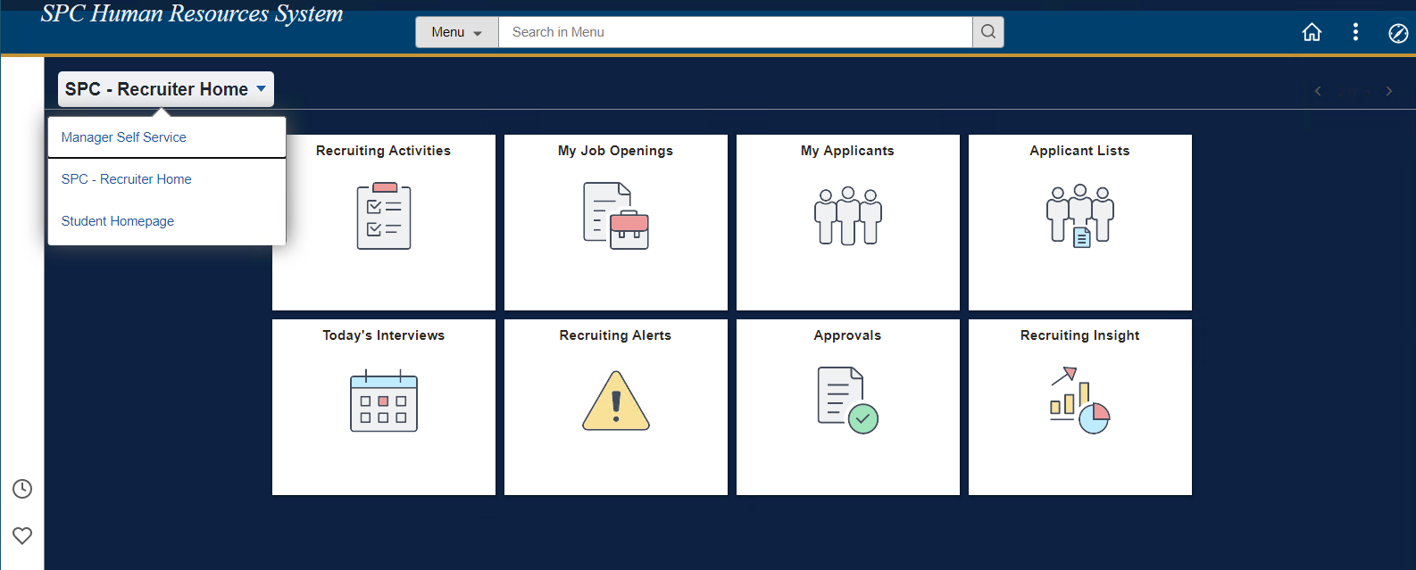  - In the ‘Recruiting Activities’ tile, navigate to ‘Create Job Opening’ link.  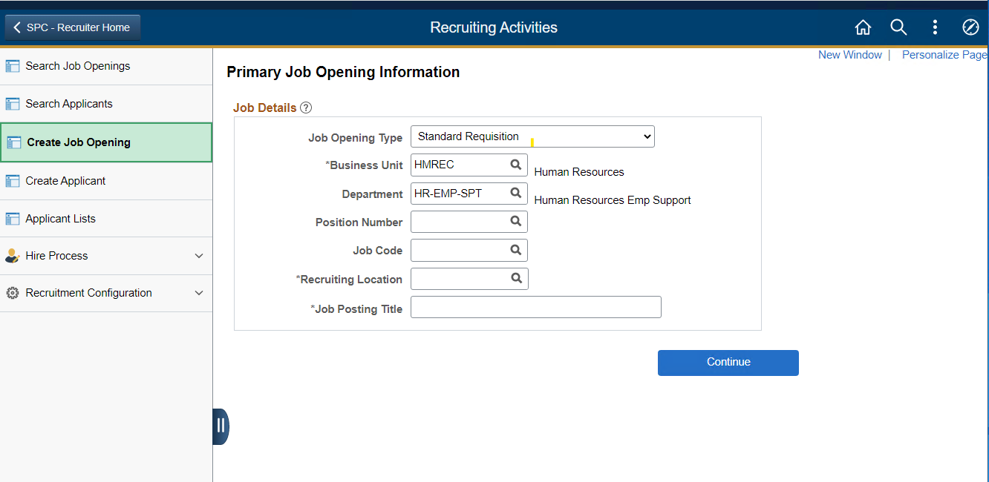

Instructions
Step 1 | Primary Job Opening Information  - Job Opening Type is defaulted to ‘Standard Requisition’, user can alternatively chose ‘Continuous Job Opening’  - Business Unit and Department are defaulted based user’s organization  - Enter either a Position Number or Jobcode and system will default Job Posting Title  - Enter a Recruiting Location from the available look up options.  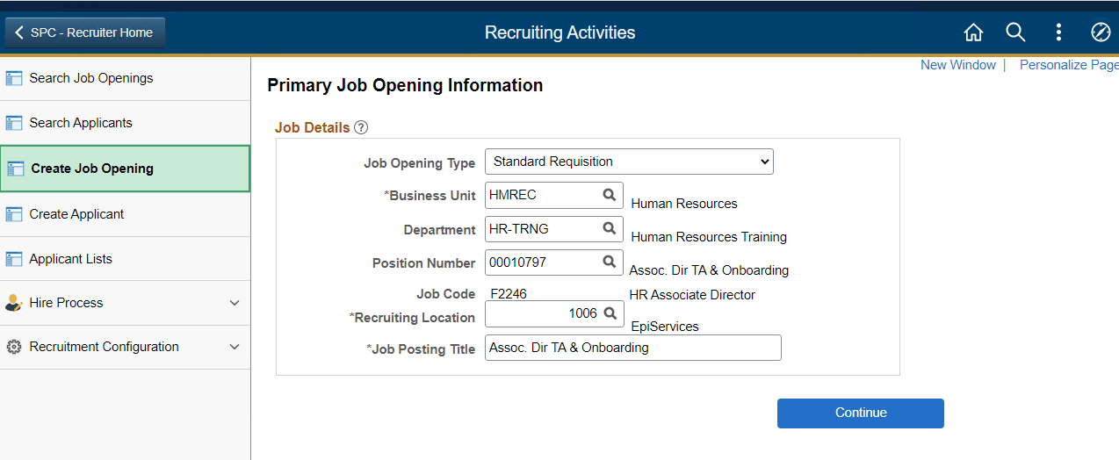
Step 2 | Job Opening – Details Page  - Data entered on the Primary Job Opening Information page (step 1) is displayed in the header  - Notice Job Opening ID – NEW and the Status is 005 Draft  - Job Opening contains multiple sections of data  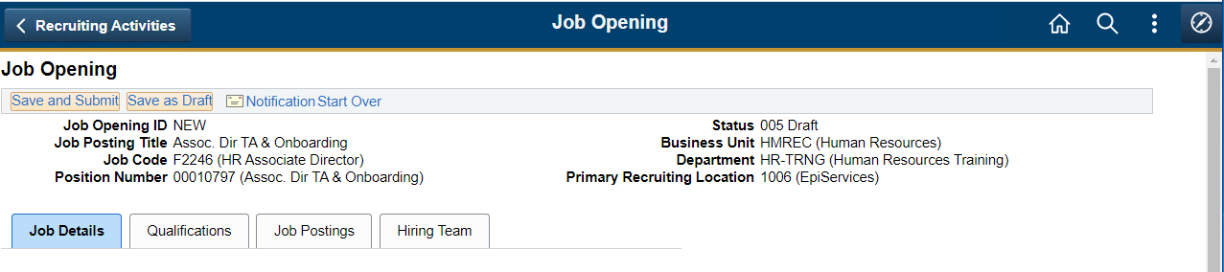  - Click on ‘Save as Draft’ button to save the job opening and generate a unique Job Opening ID  - Continue to save the job opening as you complete data entry on each page.  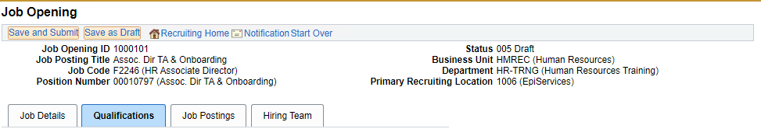
Step 3 | Job Opening - Job Details Page  - Use ‘Opening Information’ section to enter basic organizational information about the job opening.  - Enter the number of openings to fill in this job opening. Default value is 1.  - Populate the date fields if the information is available  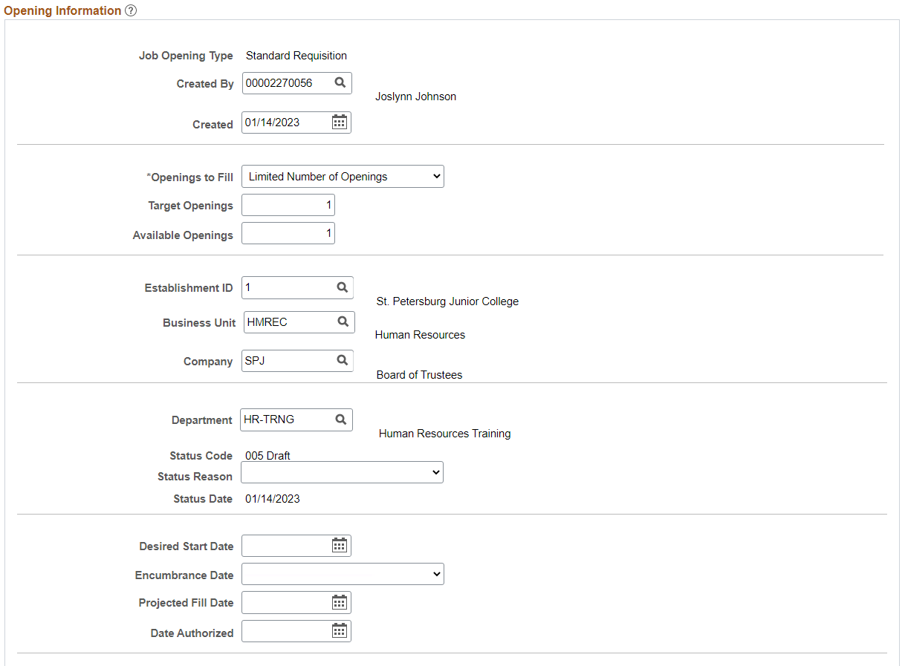  - Locations represent your organization’s physical locations as defined in HR Module  - Recruiting locations are the locations that are visible to applicants in the job portal  - Values are defaulted based on Position or Jobcode  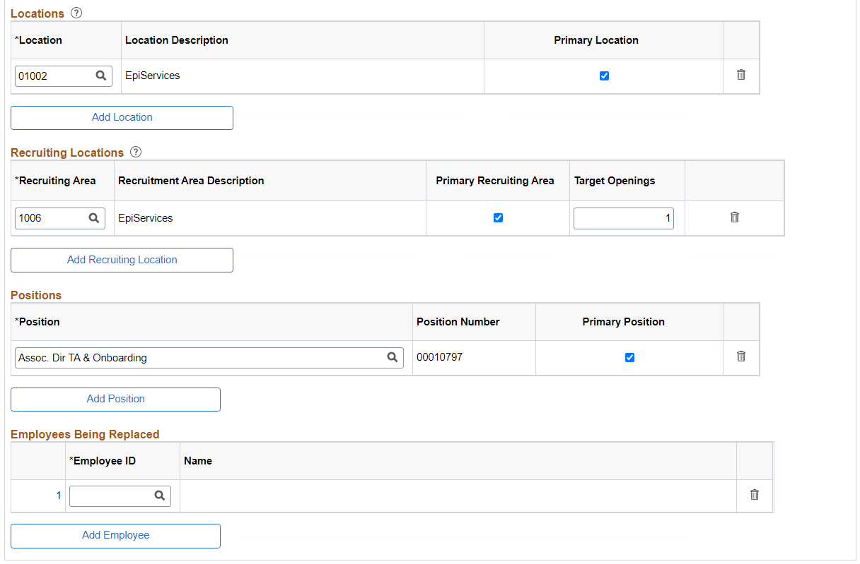  - Enter staffing information for a job opening, including data about the work schedule, travel percentage, full-time or part-time status, and regular or temporary status.  - Salary information for a job opening is defaulted based on Jobcode and is for read-only purpose  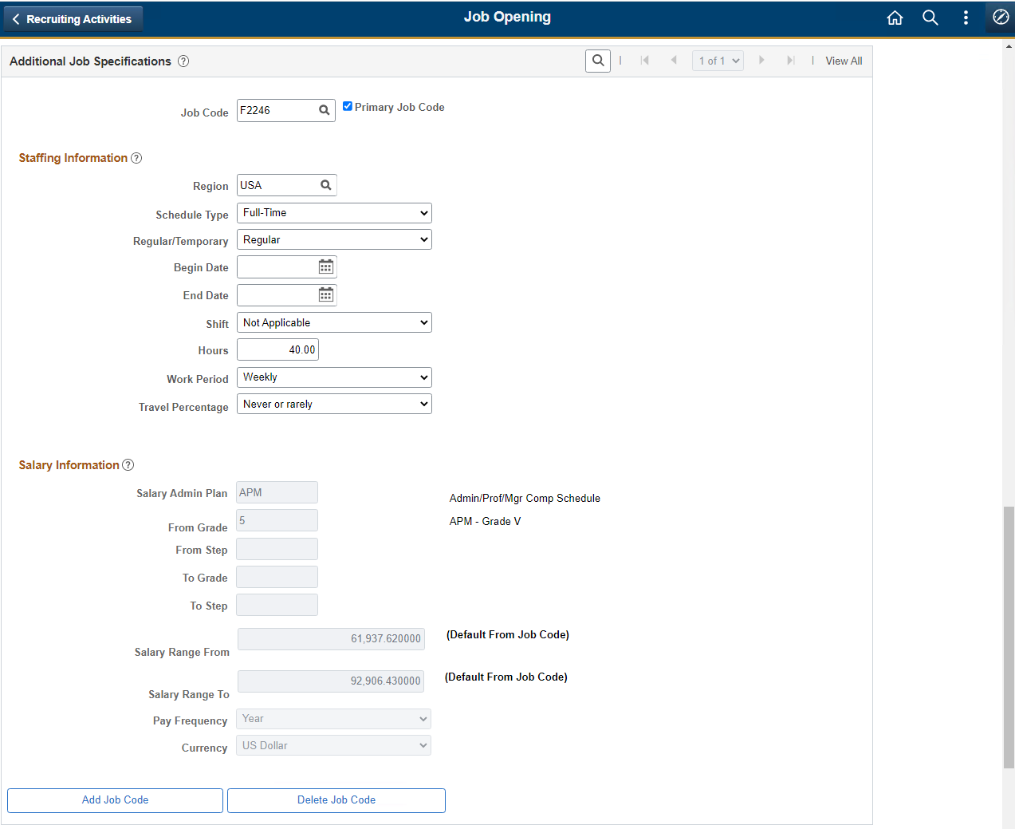  - Use the “SPC Job Data” section to enter ‘Employee Classification’ and ‘Cost Center’. At least 1 cost center is mandatory to submit a Job Opening.  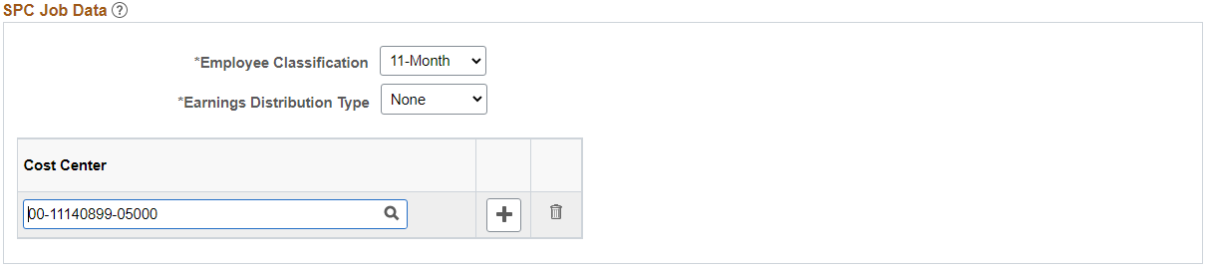  - You can split the allocate across multiple cost centers by Percent or Amount. Example below.  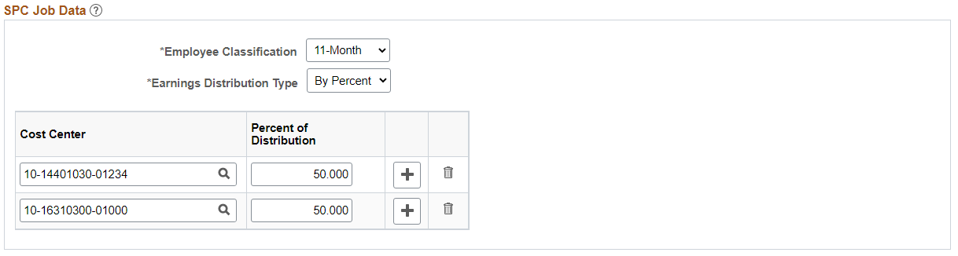
Step 4 | Job Opening - Qualifications Page  - Enter desired Qualification attributes like Highest Education Level and Work Experience. These entries are used for automated screening process (if enabled)  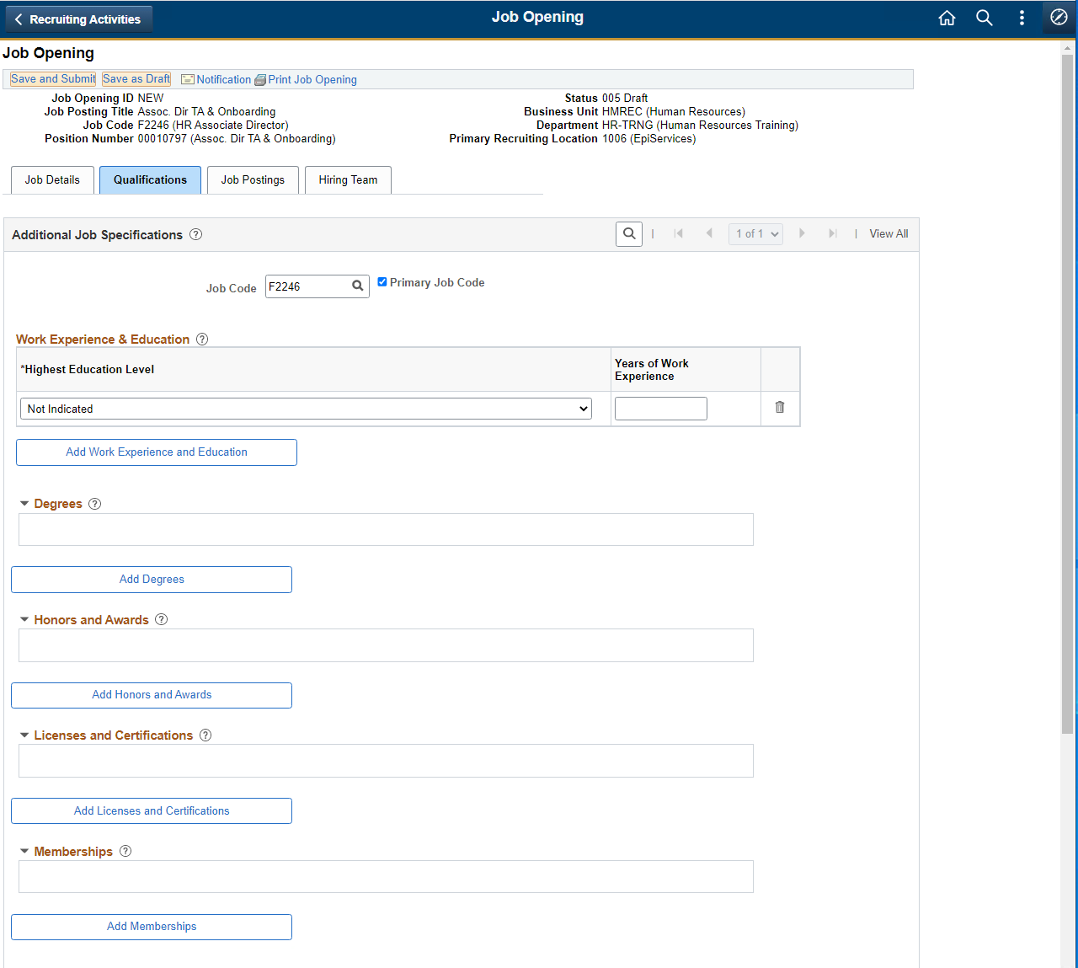  - Note that screening questions are loaded and marked as default.  - Click on ‘Pre Screening’ hyperlink to select the pre-qualification questions.  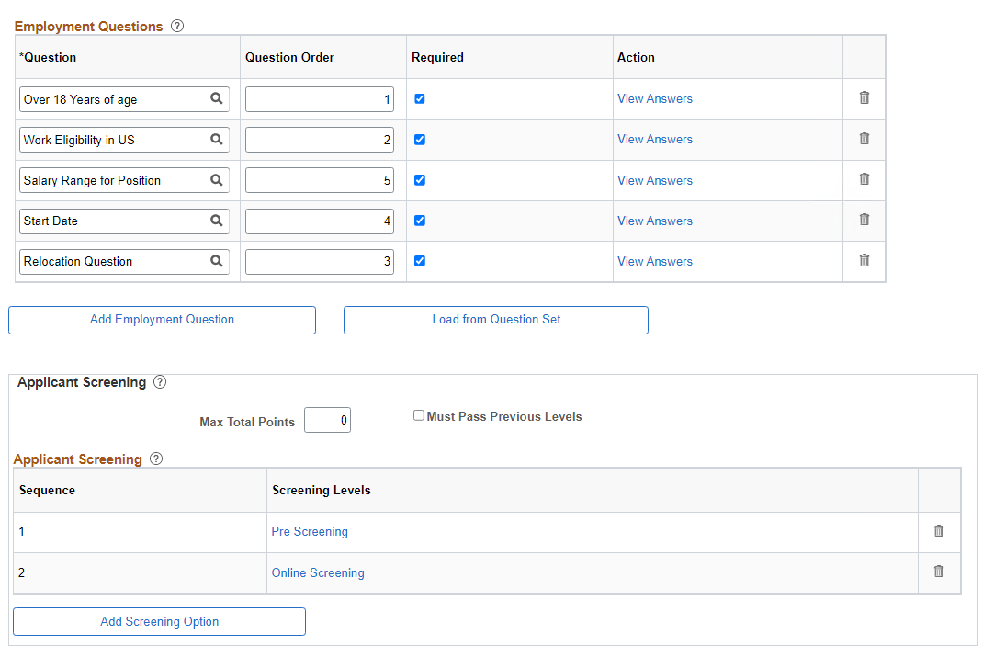
- In the ‘Screening Criteria’ page, select the flags ‘Use in Screening’ and ‘Required to Pass’ for the first 2 questions.
- Click OK to return to main page.
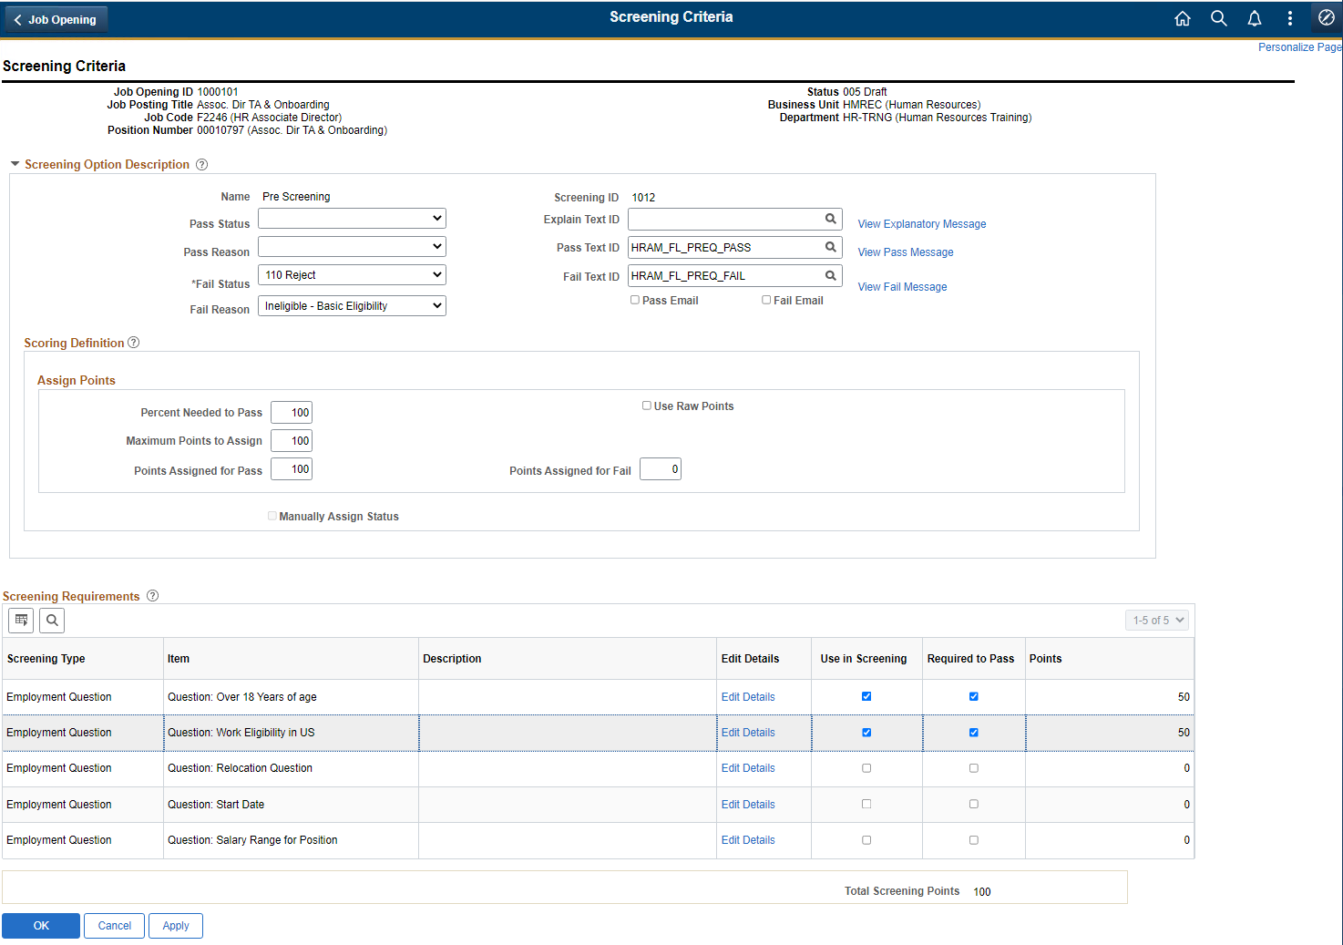
Step 6 | Job Opening – Job Postings Page  - Job Posting page allows users to create a Posting (advertisement) for a Job Opening. Click on ‘Add a Job Posting’ link to access the posting information page.  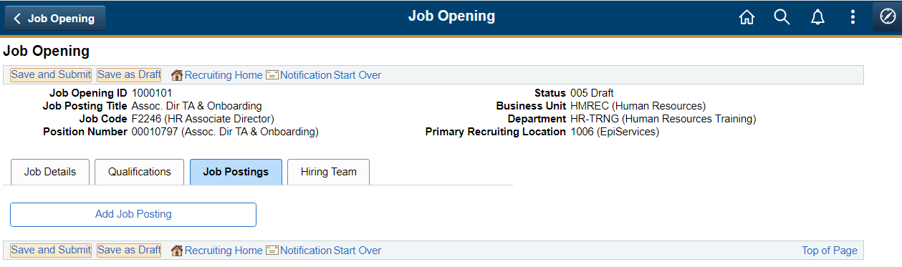  - ‘Positing Title’ is the title of the job advert that will be posted on the job portal. Review and edit as needed.  - Use “Description Type” field to select the ‘Job Series’ information.  - Use the “Description” field to select ‘Classification Series’ information.  Note: When the Description field is selected, the pre-defined job posting content from the library will be populated in the section below.  Note: Pre-defined posting description is only a template and needs to be reviewed and updated to meet the requirements of the specific job that needs to be advertised.  - Set ‘Visibility’ to Internal or External or Both.  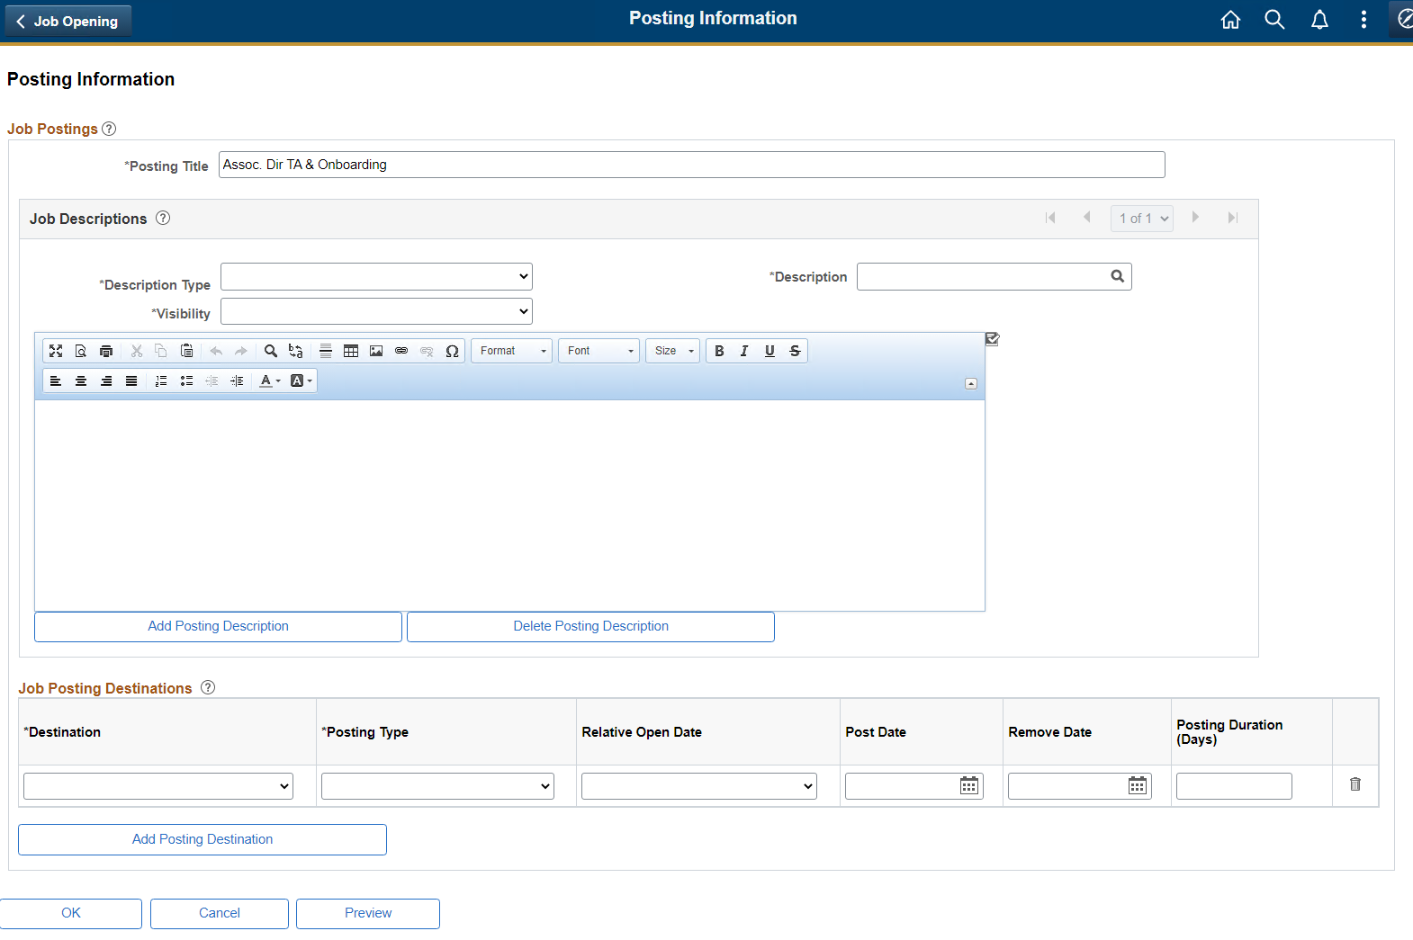  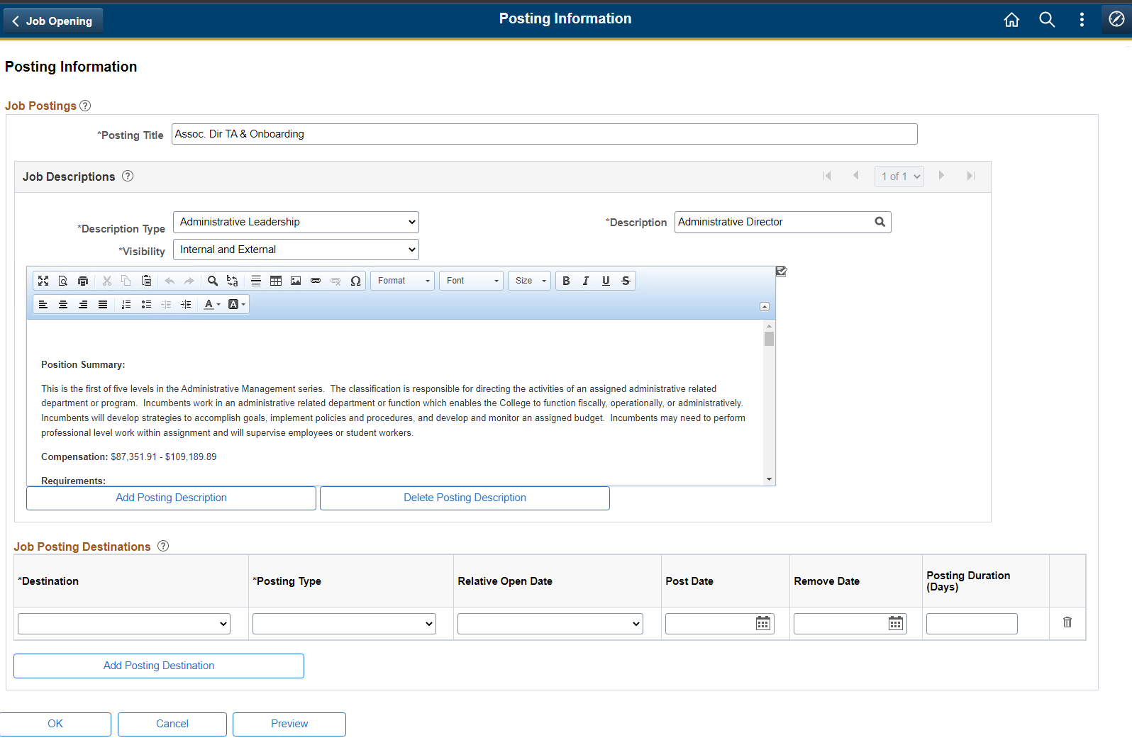  - In the ‘Job Posting Destination’ section enter 2 destinations to post the job.  - Internet – For external candidates to see and apply for this job  - Intranet – For internal employees to see and apply for this job  - Chose the Post Date and Remove Date as per requirement  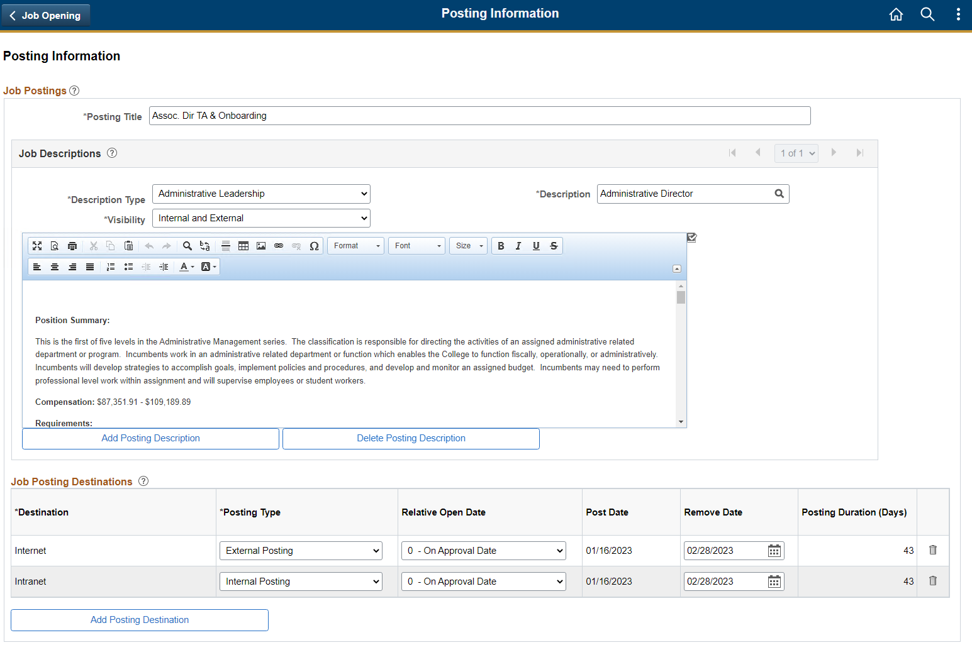  - Click OK on the bottom of the page to return to the main page.
Step 7 | Job Opening – Hiring Team Page  - Use the ‘Assignments’ section on the Job Opening page to select recruiters, hiring managers, and other members of the hiring team.  - Recruiter section is pre-populated with the list of recruiters and one recruiter is defaulted as Primary.  - You can change the Primary Recruiter as needed for this specific Job Opening.  - Use the “Add Hiring Manager” button to add one or more Hiring Managers for this Job Opening  - Optionally, ‘Add Interview’ button to add one or more Interviewers for this Job Opening  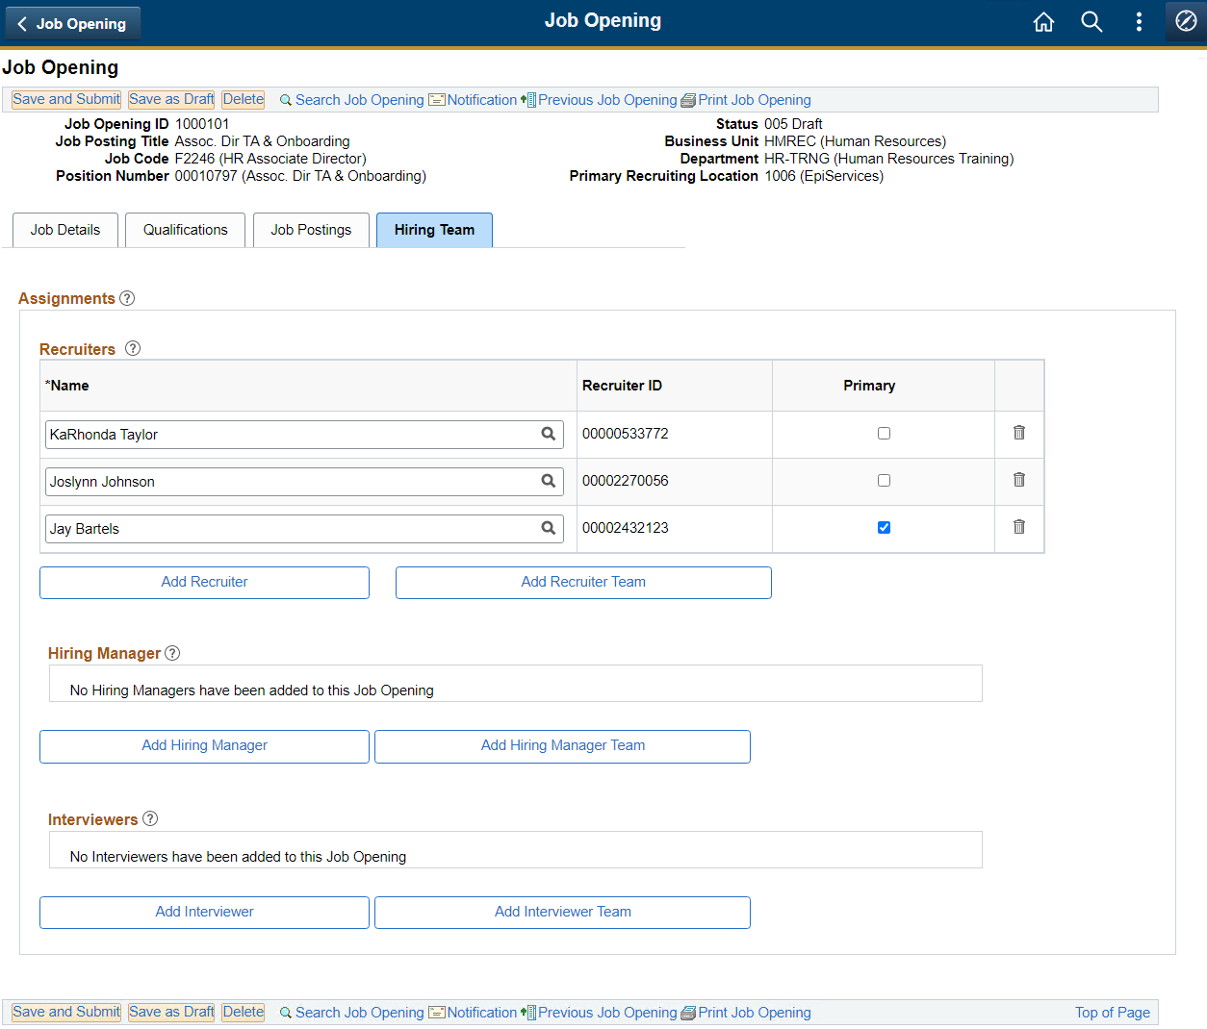  Example (Hiring Manager and Interviewers):  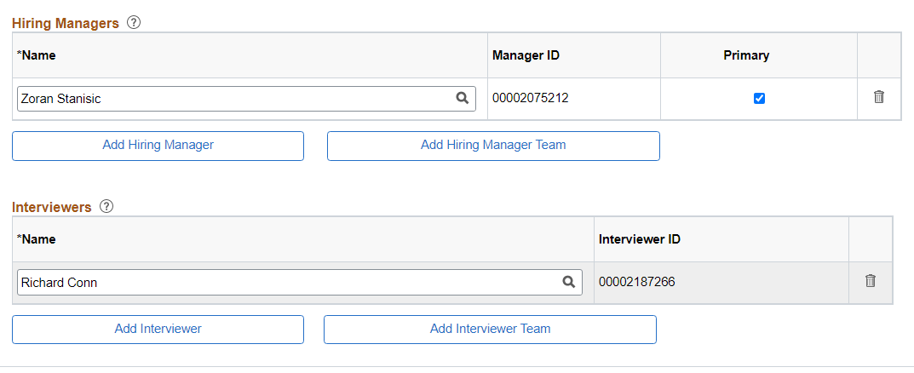
Step 8 | Save or Submit Job Opening  - Once the Job Opening has been updated with all the required details. Proceed to submit it for approval.  - Use the ‘Save and Submit’ button on the top or bottom of the page. If any mandatory fields are missing, system will provide validation message to complete the missing fields.  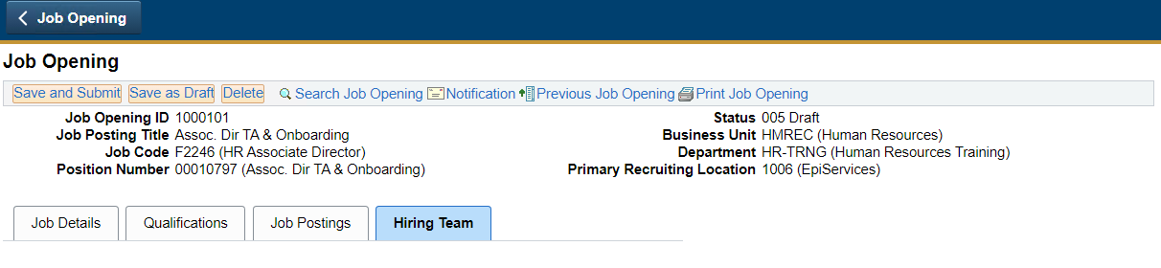  - When the Job Opening is successfully submitted, its status will change to ‘006 Pending Approval’  - A new tab ‘Approvals’ will appear that shows the list of approvers who need to approve this Job Opening, before it is posted to the job portal for recruitment  - Every Job Opening require following approval level  - Budget Supervisor Approver – Determined based on the Cost Center  - Supervisor Approver – Based on the Hiring Manager’s supervisor  - Budget Department – Based on Budget Department Role  - Vice President – Based on the Org Structure  - HR Department – Recruiting Team  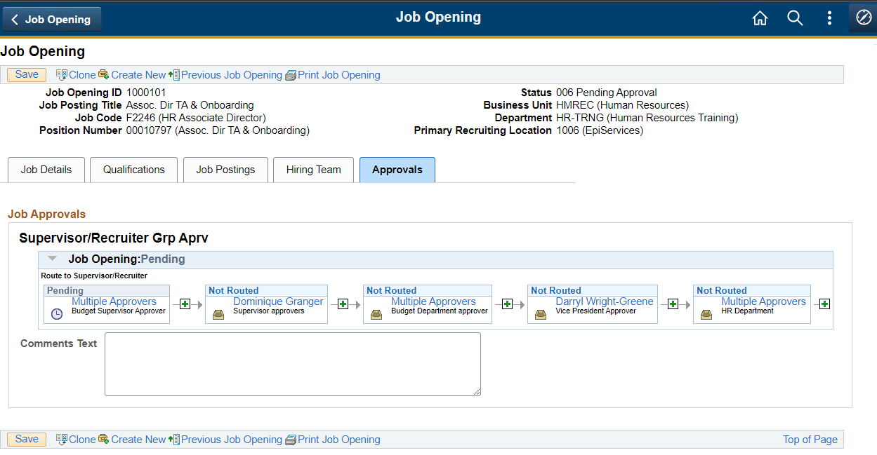  End of Task – Create Job Opening
Navigation | Accessing an Saved or Submitted Job Opening  A Job Opening that has been saved or submitted can be accessed from following navigation,  - Login to SPC Human Resource System  - In the list of homepages, select ‘SPC Recruiter Home’  - In the list of tiles, select ‘Recruiting Activities’  - In the ‘Recruiting Activities’ tile, you will land on the ’Search Job Opening’ page.  - In the ‘Search Criteria’ section to look for specific Job Openings. E.g. Use Status field to look for Job Openings that are Pending’  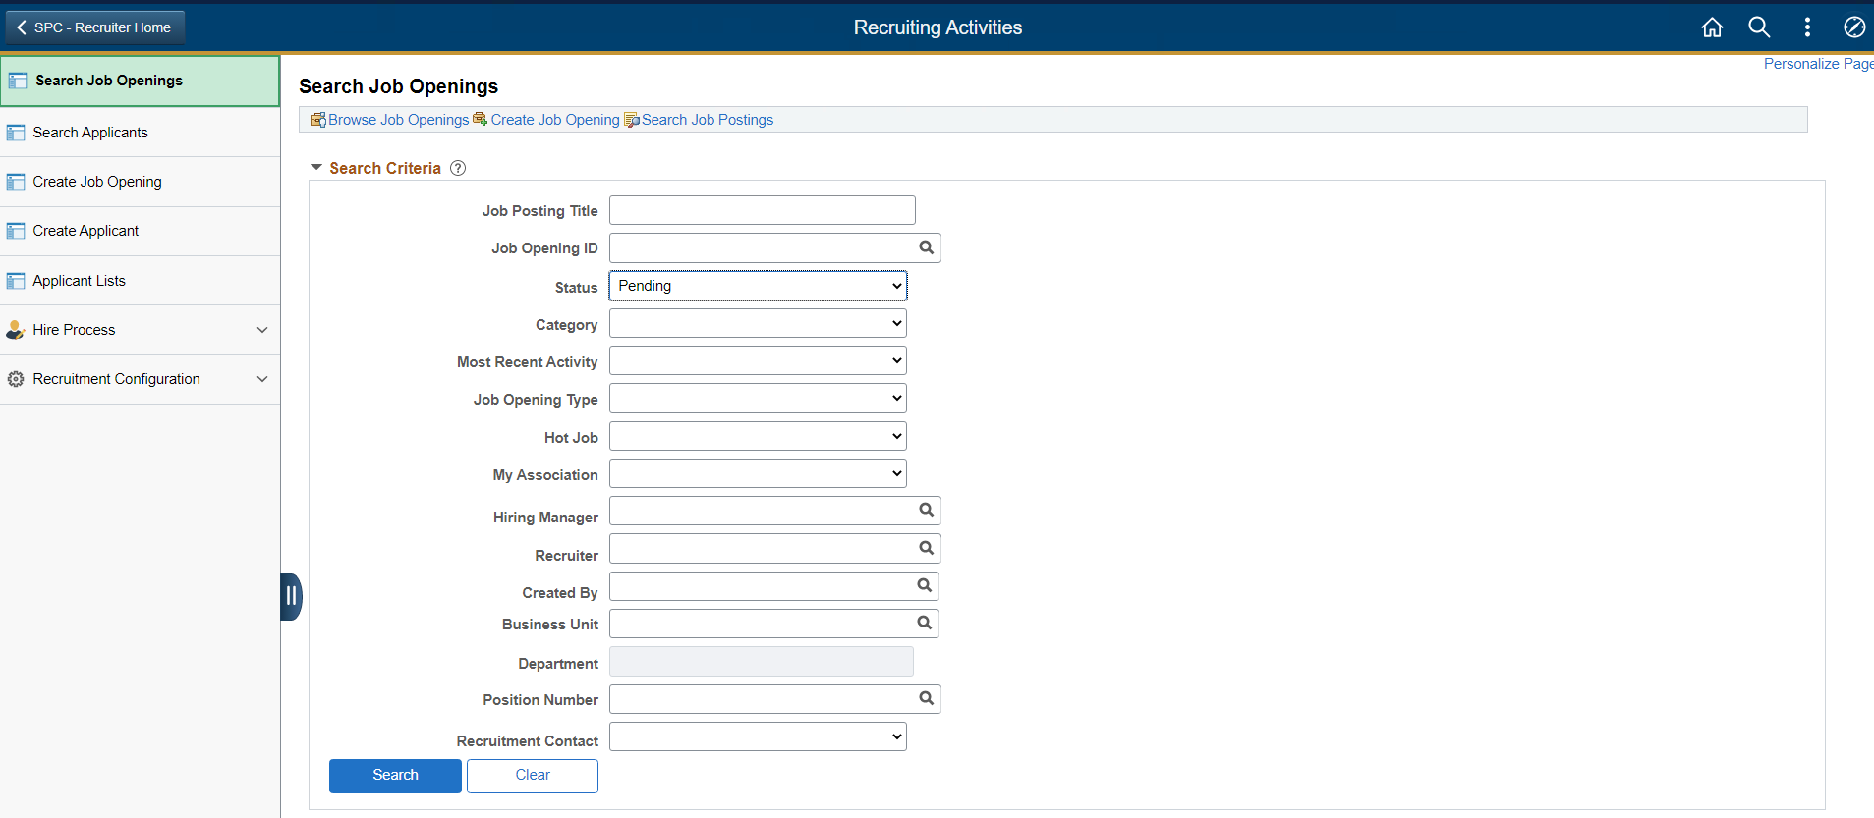  - Search results will show the list of Job Openings that are pending approval  - Click on the Job Opening title to open the Job Opening for reviewing the details.  